The sessions of the JERICO-NEXT Summer School will be recorded by ‘Lecture Capture’ technology. This allows the recording of all classroom-based activities which will subsequently be made available for viewing. Although such a resource is not a substitute and will not replace face-to-face teaching, it will provide students an aid for revision. This will also allow the content delivered during the Malta Summer School to reach a wider audience.

A number of hands-on sessions will be delivered in a computer lab equipped with audio-visual facilities. Each participant will be provided with a workstation on which all software required will be installed. A University of Malta computer account will also be provided for Wi-Fi connectivity throughout the campus and residence.

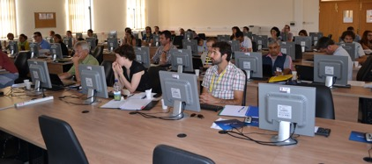
Computer lab during Malta Summer School 2013

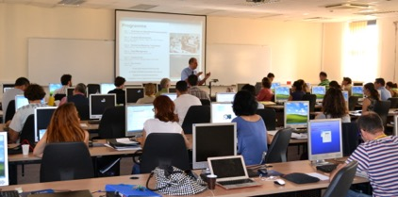
Computer lab during Malta Summer School 2013

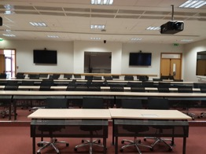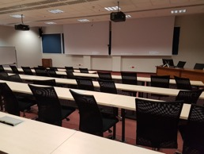
Lecture Capture facility to be used during
JERICO-NEXT Malta Summer School 2018

