Joint European Research Infrastructure network for Coastal Observatories



ILC Evaluation report
Conductivity/Salinity
Temperature/Dissolved Oxygen

Authors: F. Salvetat
Involved Institutions: Ifremer
Version and Date: Version 2.1 – 10/06/2013

Table of Contents

Table of Contents 3
1. Document description 4
2. Introduction 6
3. Main Report 7
4. Stability testing 9
5. Participants and sensors 10
6. Results 12
6.1. Introduction 12
6.2. Evaluation of the participant’s results 12
7. Conclusions 17
Annexes and References 18

- Document description

REFERENCES

Document information
Document Name | Evaluation report Conductivity/Salinity Temperature/Dissolved Oxygen
Document ID | JERICO –WP1- Rep-ILC1-100613-V1
Revision | 1.0
Revision Date | 10 June 2013
Author | F. Salvetat
Security

History
Revision | Date | Modification | Author
2 | June 2013 | Correction | Patrick FARCY
2.1 | June 2013 | Correction | Yannick AOUSTIN

Diffusion list
Consortium beneficiaries | X
Third parties
Associated Partners

This document contains information, which is proprietary to the JERICO consortium. Neither this document nor the information contained herein shall be used, duplicated or communicated by any means to any third party, in whole or in parts, except with prior written consent of the JERICO Coordinator.
The information in this document is provided as is and no guarantee or warranty is given that the information is fit for any particular purpose. The user thereof uses the information at its sole risk and liability.

The work that is described in this report is carried out by:

Ifremer

Centre de Bretagne

Technopole de Brets Iroise

CS 10070

29280 Plouzané

The following members of the staff were involved:

F. Salvetat Head of the Metrology Laboratory

C. Le Bihan Deputy to the Head of the Metrology Laboratory

The work was carried out from the 8th to the 12th of October 2012.

Signature | Approved
F. Salvetat   | G.Petihakis P.Farcy  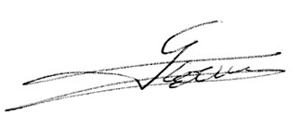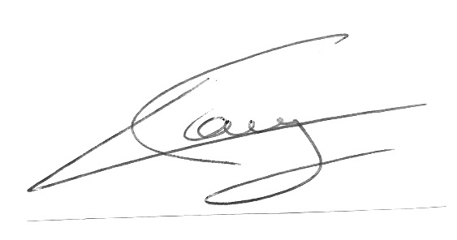
Date | Date
13/06/2013 | 18/11/2013

- Introduction

Complemental to the first FCT workshop, the metrology laboratory of Ifremer Centre de Bretagne carried out a calibration experiment from the 8th to the 12th of October 2012. This experiment was promoted by the Jerico European project (JOINT EUROPEAN RESEARCH INFRASTRUCTURE NETWORK FOR COASTAL OBSERVATORIES), in the framework of a collaborative work proposed by the workpackage 4, “Maintenance and Calibration”, and the “Forum for Coastal Technologies”.
The purpose of this experiment was to compare the calibration methods used by different institutes or firms within an inter-laboratory comparison (ILC). In terms of metrology, this comparison will allow the laboratories to assess their performance with respect to the calibration of their sensors. The parameters under investigation were temperature, salinity (conductivity) and dissolved oxygen.
To simplify the process and to shorten the time devoted to the comparison, Ifremer proposed to carry out for each participant, a bilateral comparison (Ifremer vs participant) on one or several sensors owned by the participant. All comparisons were simultaneous.
The objective (institutes performance) was achieved by comparing the calibration results of the regular calibration of the sensors of the participants with the reference calibrations performed by the coordinating laboratory, the metrology laboratory of Ifremer.
The evaluation of the performance was carried out using the reported deviations and/or corrections and corresponding uncertainties of the participants with respect to the measured deviations/corrections and corresponding uncertainties by the reference laboratory. From these values, we could calculate the normalized errors (En scores). En scores ≤ 1 are satisfactory, whereas En >1 is rated unsatisfactory.

- Main Report

Proposed protocol:
The proposed protocol for the reference calibration carried out at Ifremer with the participants is the following:
Date | Sensors | Description
Monday afternoon | All probes | - Installation of probes in the conductivity/temperature bath  - Visit of metrology laboratory and nutrients laboratory
Tuesday morning | Conductivity/Salinity/Temperature | Calibration at salinity 35 and temperature 5°C
Tuesday afternoon | Conductivity/Salinity/Temperature | Calibration at salinity 35 and temperature 15°C
Wednesday morning | Conductivity/Salinity/Temperature | Calibration at salinity 10 and temperature 15°C
Wednesday afternoon | Conductivity/Salinity/Temperature | - Calibration at salinity 17 and temperature 15°C  - Installation of probes in the oxygen bench
Thursday morning | Dissolved Oxygen/Temperature | Calibration at O2: 100% (air equilibrium or nitrogen/oxygen bubbling) and temperature 20°C (salinity: 0)
Thursday afternoon | Dissolved Oxygen/Temperature | Calibration at O2: 100% (air equilibrium or nitrogen/oxygen bubbling) and temperature 10°C (salinity: 0)
Friday morning | Dissolved Oxygen/Temperature | Calibration at O2: 50% (nitrogen/oxygen bubbling) and temperature 20°C or 10°C (salinity: 0)

Modification of the protocol:
After discussion with the participants, the schedule was modified as follows (modifications in blue):
Date | Sensors | Description
Monday afternoon | All probes | - Installation of probes in the conductivity/temperature bath  - Visit of metrology laboratory and nutrients laboratory
Tuesday morning | Conductivity/Salinity/Temperature | Calibration at salinity 35 and temperature 5°C
Tuesday afternoon | Conductivity/Salinity/Temperature | Calibration at salinity 35 and temperature 15°C
Wednesday morning | Conductivity/Salinity/Temperature | Calibration at salinity 17 and temperature 15°C
Wednesday afternoon | Conductivity/Salinity/Temperature | - Calibration at salinity 10 and temperature 20°C  - Installation of probes in the oxygen bench
Thursday morning | Dissolved Oxygen/Temperature | Calibration at O2: 100% (air equilibrium or nitrogen/oxygen bubbling) and temperature 20°C (salinity: 0)
Thursday afternoon |  | Calibration at O2: 50% (nitrogen/oxygen bubbling) and temperature 20°C (salinity: 0)
Friday morning |  | Calibration at O2: 100% (air equilibrium or nitrogen/oxygen bubbling) and temperature 10°C (salinity: 0)

All measurements were performed at Ifremer metrology laboratory. The measures were collected jointly by the participants and the coordinating laboratory, except for the measures of the CNR-ISMAR that needed post processing from Elio Paschini.
The participants were asked to give the coordinating laboratory the results of the regular calibration of the sensors in order to calculate the En scores.
Operating procedure:
The conductivity/temperature operating procedure and the devices used are described in the annex A. The dissolved oxygen operating procedure and the devices used are described in the annex B.

- Stability testing

Due to the ILC protocol (sensors owned by the participants), no stability testing were performed on the sensors.

- Participants and sensors

The 4 participating laboratories are:
• HCMR (Greece): Tanya Tsagaraki, Manolis Ntoumas and George Petihakis
Sbe37-SIP CT sensor and Aandera 3830 DO optode
• CNR-ISMAR (Italy): Stefania Sparnocchia and Elio Paschini
Sbe19 plus CTD sensor and Sbe43 DO sensor
• AZTI Tecnalia (Spain): Carlos Hernandez
Sbe37-SMP CTD sensor
• NIVA (Norvège): Emanuele Reggiani
Aandera 3830 DO optode

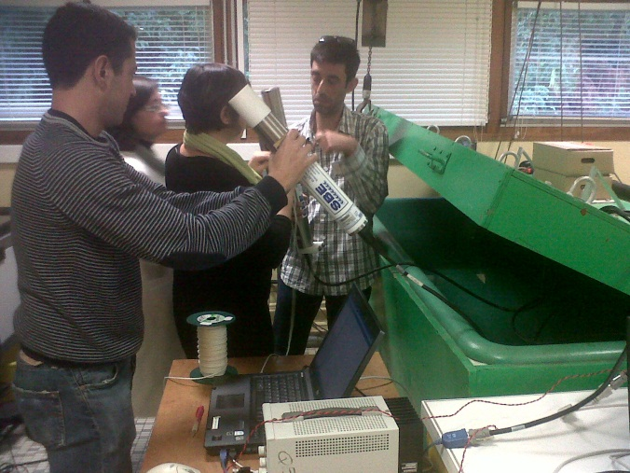 | 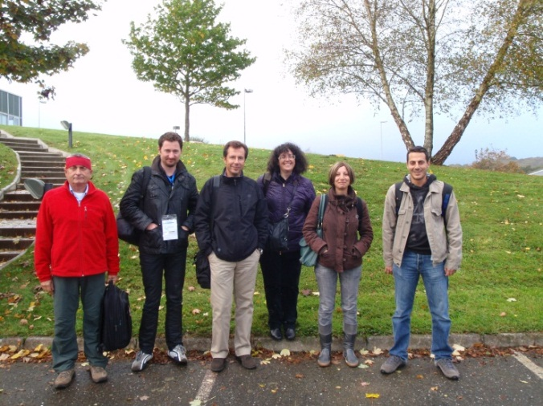
The participants
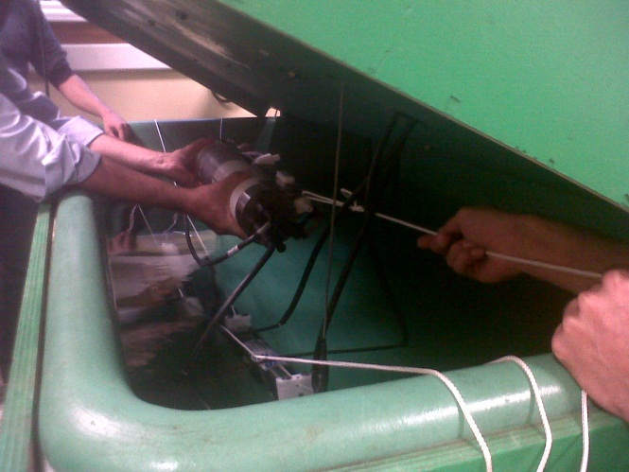 | 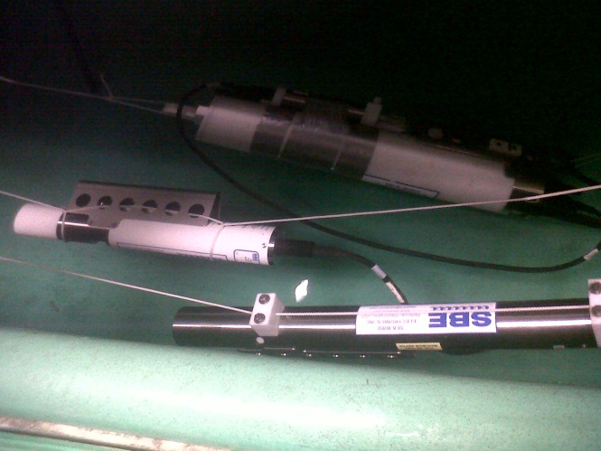
Conductivity and temperature ILC
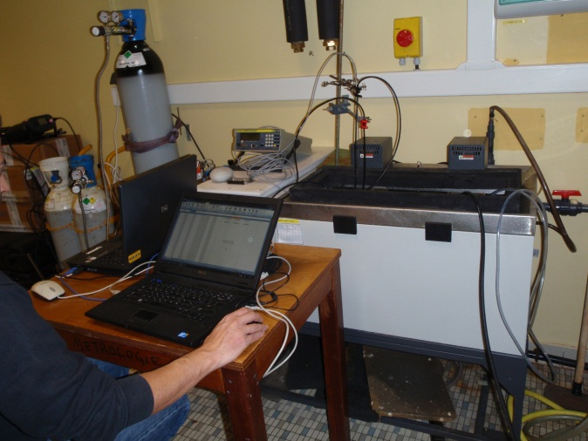 | 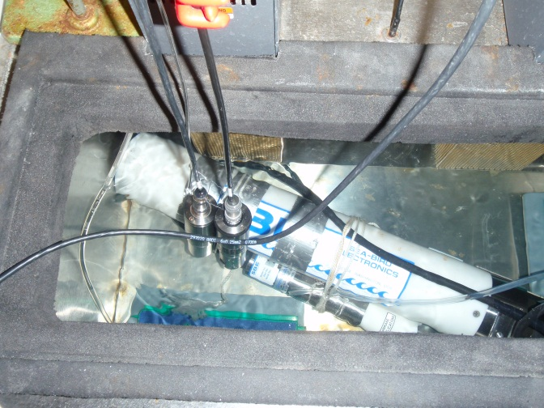
Dissolved oxygen ILC

- Results

Introduction

All participating laboratories have attended the reference calibration at Ifremer.
However, not all participants submitted their results with complete information:
• CNR-ISMAR did not send the results of the first level of temperature and conductivity (which needed post processing) and did not produce the results of the regular calibration of their sensor.
• NIVA did not produce the results of the regular calibration of their sensor.

Evaluation of the participant’s results

The results of the participants should have been evaluated by means of:
• trueness errors,
• En scores
()

However, as the participants displayed manufacturer calibrations without evaluation of the uncertainties of the calibration, it was impossible to calculate the En scores. When possible, we thus proposed an interpretation of the results based on the comparison of the trueness of the calibration.

Temperature and conductivity/salinity ILC
Trueness errors: (see annex C for a better view of the results)

AZTI Results:

HCMR Results:

CNR Results:

Trueness comparison:

AZTI Results:
We can see a good agreement of the sensors in terms of temperature.
In conductivity, there is a discrepancy probably due to a drift on the conductivity sensor. However, this discrepancy is not surprising seeing the 2 years elapsed between the two calibrations.

HCMR Results:
We can see a good agreement of the sensors in term of temperature.
In conductivity, there is a discrepancy probably due to a drift on the conductivity sensor. However, this discrepancy is not surprising seeing the 2 years elapsed between the two calibrations.

CNR Results:
As the CNR didn’t provide any previous calibration results, t is not possible to make any comparison. However, we can see that the temperature sensor has a small trueness error.

Dissolved oxygen ILC
Trueness errors: (see annex D for a better view of the results)
HCMR Results:

NIVA Results:

CNR Results:

Trueness comparison:

HCMR Results:
The regular calibration was carried out by the manufacturer Aanderaa in July 2011. However the calibration certificate of the manufacturer only displays phase readings and coefficients. As the concentrations of dissolved oxygen are not indicated, it is not possible to proceed to the comparison (no post processing function is indicated in the certificate and, due to the high risk of error, no post processing of the data can be done by the coordinating laboratory with the information given in the certificate).

NIVA Results:
The NIVA did not produce the results of the regular calibration of their sensor.

CNR Results:
The CNR did not produce the results of the regular calibration of their sensor.

- Conclusions
This experiment took place in a friendly atmosphere: it gave all participants the opportunity to exchange on the way sensors are calibrated in the institutes. All participants promoted transparency on their knowledge, their experience and their know how.
The experiment enabled the participants to calibrate their sensors at several temperatures, salinities and dissolved oxygen concentrations. The analysis of the results showed the sensors that were exempt of trueness errors. But for the sensors with errors, it was difficult to propose any hypothesis because of the lack of information on the sensor.
Finally, this first experiment did not fulfill the final objective which was to compare different methods of calibration. It underlined the obligation to have beforehand all the information needed to achieve the goal fixed. However, it has to be kept in mind that inter-laboratory comparisons must be performed several times to be fully efficient.

Annexes and References
Annex A: Conductivity/Temperature Operating procedure

Testing Facilities
Temperature regulated bath
Temperature regulated water bath (id. yellow bath) with mixed water to reduce temperature differences:
Effective capacity: 1500 × 650 × 600 mm.
Regulation range: - 1.5°C to + 40°C.
Salinity can be changed from fresh water to seawater.

Reference temperature measurement
- Platinum resistance thermometer ROSEMOUNT 162 CE s/n 5011 (id. R8).
- DC resistance bridge GUILDLINE 9975 s/n 39067 (id. Ifremer).
- Standard resistor 10 Ω GUILDLINE 9330 s/n 38541.
- Liquid thermometer ASTM 90C s/n 2826.

The platinum resistance thermometer is regularly calibrated by the L.N.E (Laboratoire National de métrologie et d’Essais) at three fixed points of the ITS 90: the triple point of mercury, the triple point of water and the freezing point of indium.

The estimated expanded uncertainty of the reference temperature is U = ± 0.04°C.

The expanded uncertainties indicated are equal to twice the combined standard uncertainty.
Reference salinity calculation
GUILDLINE Autosal 8400 laboratory salinometer (Set temperature: 21°C).

The salinometer is calibrated with:
- standard seawater bottle IAPSO P148 – 10 October 2006 - K15 = 0,99982 - S = 34,993;
- standard seawater bottle IAPSO 10L9 - 22 July 2004 - S = 10,025.

Salinity is calculated using the conductivity ratio measured by the salinometer and the equations recommended by UNESCO in "The Practical Salinity Scale 1978".

The estimated expanded uncertainty of the reference salinity is U = ± 1.10-2.

Reference conductivity calculation
Conductivity is calculated using the reference salinity calculation, the sensor immersion, the reference temperature measurement of the bath and the iterative equation recommended by UNESCO in 1980 with C35, 15, 0 = 42,914 mS/cm.

The estimated expanded uncertainty of the reference conductivity is U = ± 0,01 mS/cm.

Calibrated sensor interface
- PC + "Seasave" software.
- Measurement frequency: 1 measure / 15 seconds.
- Measurement period: 20 minutes.

Measurement Procedure
The instrument is completely immersed in the temperature regulated bath. It is distant from the sides of the bath to prevent any effects on measurements. The protection grid of the instrument is in place.

The immersions of the sensors are indicated with the calibration results.
The sensors of the instrument are near the reference platinum resistance thermometer. The immersion of the platinum resistance thermometer is indicated with the calibration results.

During calibration, we carry out measurements before and after removing bubbles from the sensors (shaking them) to check the potential influence of bubbles on sensors.

The laboratory staff carry out the configuration of the instrument, the recovery and the post processing of the measurement.

The instrument is always powered on.

For each temperature, we sample 3 bottles of water. Their salinity is measured by the salinometer when their temperature is around the laboratory temperature.

During measurements, the stability of the bath is better than ± 0.001°C and its drift does not exceed ± 0.002°C.

The laboratory temperature during experiment is 20.0°C ± 2.0°C.

Annex B: Dissolved oxygen Operating procedure

Testing Facilities
Temperature regulated bath
Temperature regulated water bath HART 7015 no. A8C100 with mixed water to reduce temperature differences:
Effective capacity: 700 × 280 × 300 mm.
Regulation range: - 1.5°C to + 40°C.
Salinity can be changed from fresh water to seawater.
Reference temperature measurement
- Thermometer AOIP PN5207P s/n 59069 1 D5 (id 1) and its probe AOIP AN5847 s/n A42 (id S_{1.1}).

The platinum resistance thermometer is regularly calibrated by Ifremer.

The estimated expanded uncertainty of the reference temperature is U = ± 0.04°C.

The expanded uncertainties indicated are equal to twice the combined standard uncertainty.
Reference dissolved oxygen measurement
- Sampling bottles which volume has been measured in April 2012.
- METROHM Titrino Plus 848 automatic titrator filled with a 0.02N thiosulfate solution.
- Winkler Reagents as described in the book « Hydrologie des écosystèmes marins, paramètres et analyses » from Alain Aminot and Roger Kérouel.
Calibrated sensor interface
- PC + "Hyper Terminal" software.
- Measurement frequency: 1 measure / 15 seconds.
- Measurement period: 20 minutes.
Measurement Procedure
The instrument is completely immersed in the temperature regulated bath.

The sensor of the instrument is near the reference platinum resistance thermometer.

Bath water is sampled in three bottles and then analysed following the Winkler method described in the book « Hydrologie des écosystèmes marins, paramètres et analyses » by Alain Aminot and Roger Kérouel.

An estimation of the concentration of the sodium thiosulfate is performed before the analysis of the samples.

The laboratory staff carry out the configuration of the instrument, the recovery and the post processing of the measurement.

The instrument is constantly powered on.

During measurements, the stability and the drift of the bath are better than ± 0.001°C.

The laboratory temperature during experiment is 20.0°C ± 2.0°C.

Annex C: Temperature and conductivity/salinity calibration results
AZTI Results:

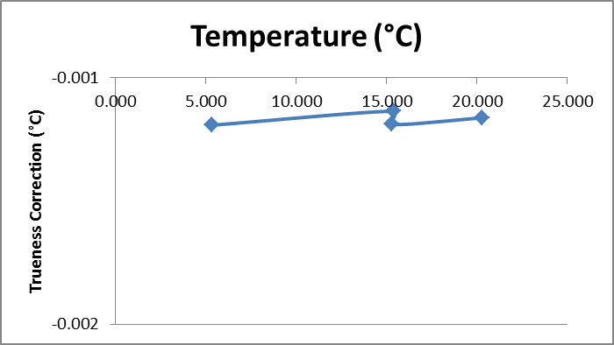
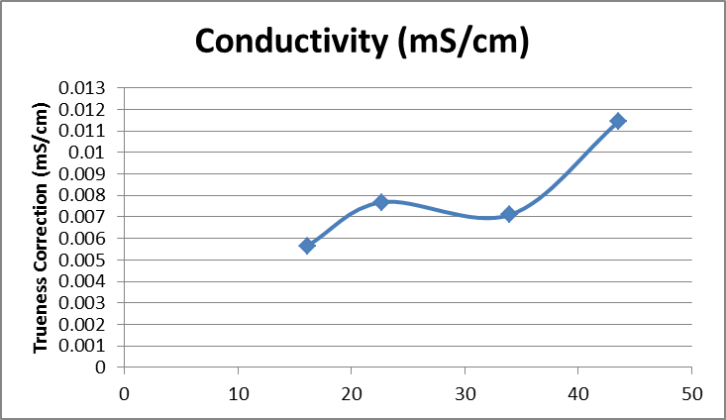 | 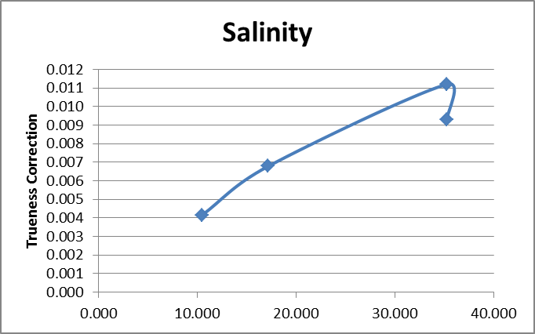
HCMR Results:

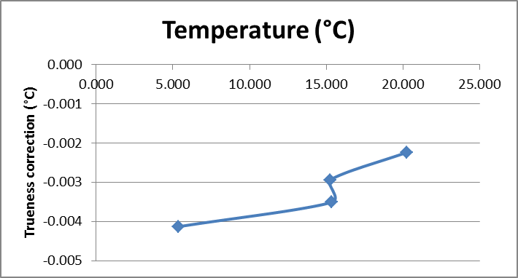
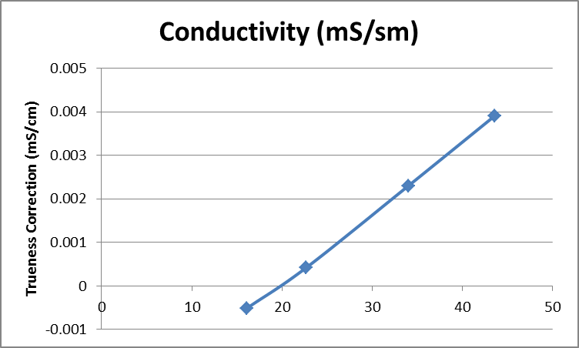 | 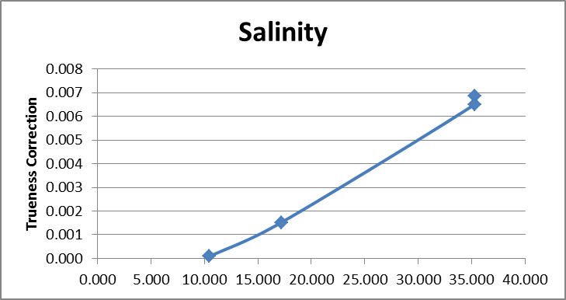
CNR Results:

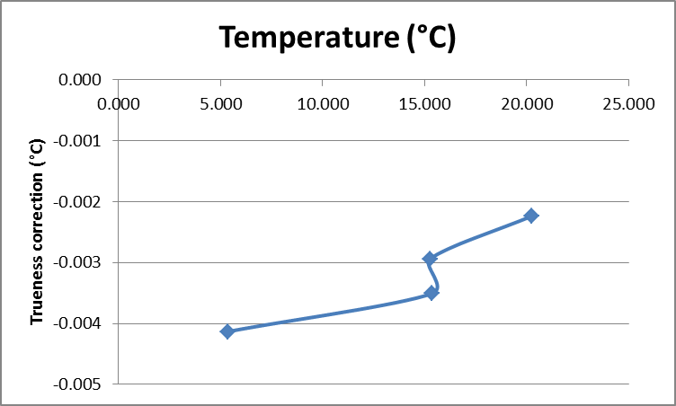
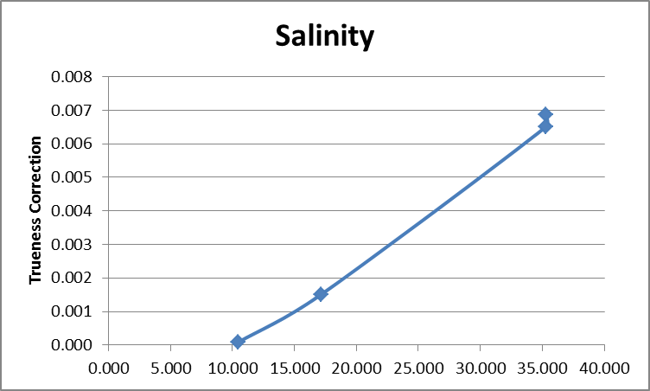
Annex D: Dissolved Oxygen calibration results

HCMR Results:

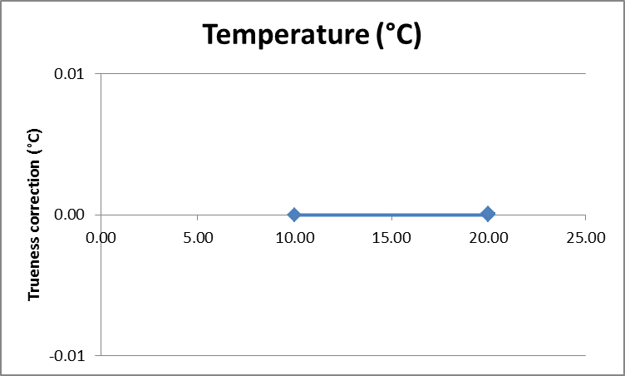 | 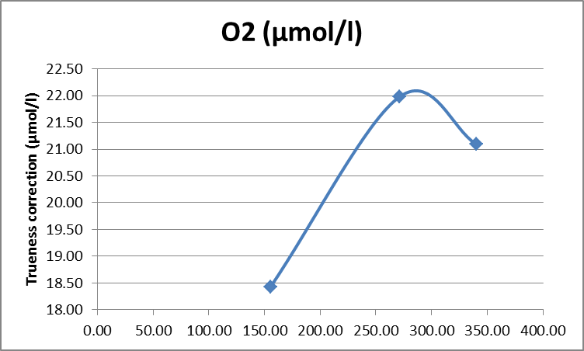

NIVA Results:

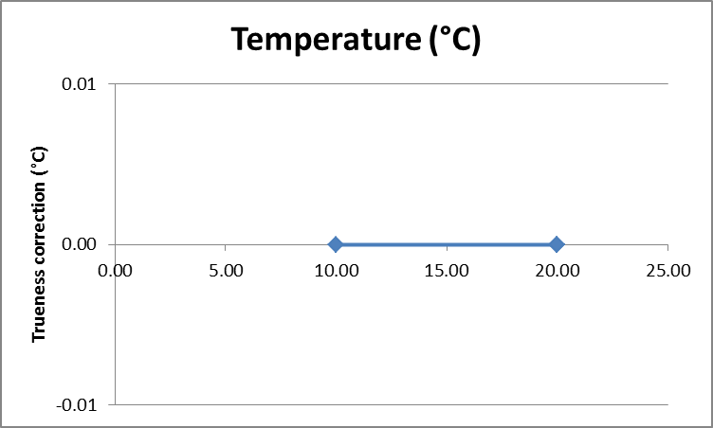 | 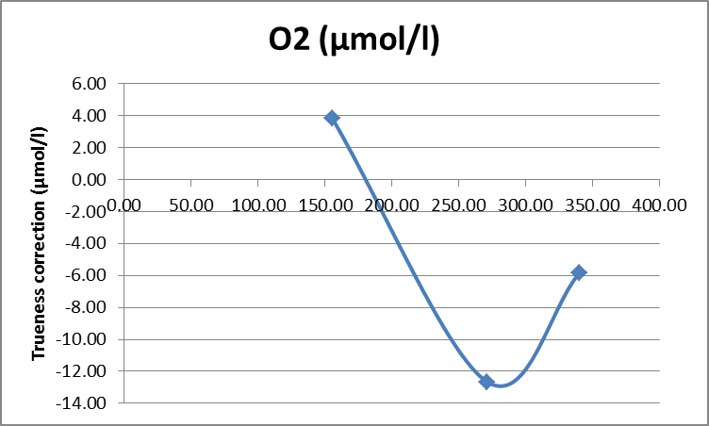

CNR Results:

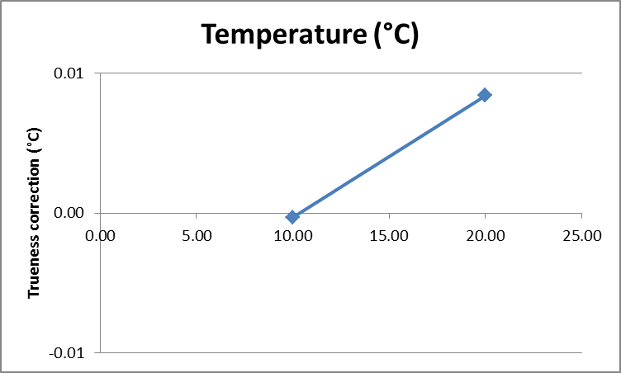 | 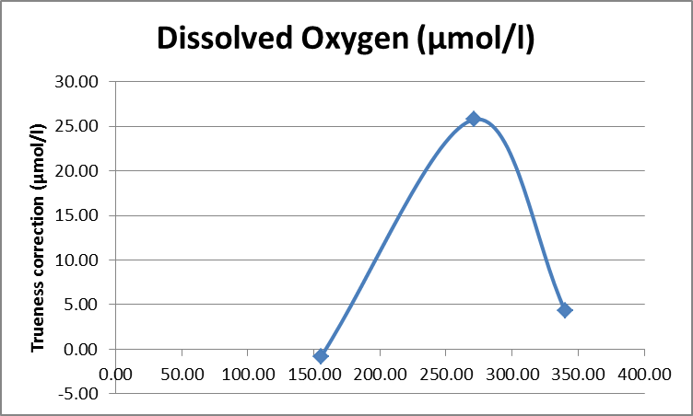

Acknowledgements:

We thank all participants for their enthusiasm and the exchange of experience and knowledge that were possible during the experiment.

