Design and launching of Jerico OceanBoard

Grant Agreement n° 262584
Project Acronym: JERICO
Project Title: Towards a Joint European Research Infrastructure network for Coastal Observatories
Coordination: P. Farcy, IFREMER,
jerico@ifremer.fr, www.jerico-fp7.eu:

Authors: Prof. Aldo Drago, Angele Giuliano
Involved Institution: UOM, University of Malta
Date: 2012-02-29

Document description

REFERENCES

Annex 1 to the Contract: Description of Work (DoW) version 2011-02-22

Document information
Document Name | Design and launching of Jerico OceanBoard
Document ID | JERICO-WP6-D6.1-120229-V1
Revision | 1
Revision Date | 2012-02-29
Author | Prof. Aldo Drago, Angele Giuliano
Security

History
Revision | Date | Modification | Author

Diffusion list
Consortium beneficiaries | X
Third parties
Associated Partners

This document contains information, which is proprietary to the JERICO consortium. Neither this document nor the information contained herein shall be used, duplicated or communicated by any means to any third party, in whole or in parts, except with prior written consent of the JERICO Coordinator.
The information in this document is provided as is and no guarantee or warranty is given that the information is fit for any particular purpose. The user thereof uses the information at its sole risk and liability.

This document serves as deliverable for the WP6, Outreach and Education, on the OceanBoard.
The Nature of D6.1 deliverable is a prototype of webserver (accessible at address www.jerico-fp7.eu)

Brief Description of the Initiative

The OceanBoard will act as an information portal to news items, events and data; it constitutes the educational component of the JERICO information portal; providing an online educational and information resource through a web environment within the JERICO Community Hub
The JERICO OceanBoard will work similarly to a news agency - publishing news items, features and contributions from different sources (mainly within the partnership, but also from outside), reporting on interesting activities relating mainly to the project partner achievements whilst also reporting on operational oceanography and marine observations in general and on interesting related programmes, projects, events, uses and derived services that appeal to public outreach. Its main targets include:
- Gaining societal support for sustained observations and monitoring of the marine environment
- Raising awareness on the benefits and potential of coastal observations to promote sustainable development of the coastal zone;
- Disseminating experience, examples and guidelines on the use of derived products and services (especially targeting environmental managers and industry-related applications with specific examples);
- Building the future generations of professionals by supporting students and young scientists with high level articles or learning features on related thematic

Target Audience of the OceanBoard
There are various audiences at which the OceanBoard is targeted:
- Academia and professionals interested in oceanography (including technology and engineering),
- Stakeholders within the public service (policy managers and decision makers),
- The general public (including younger generations) to reach the wider interests and needs of a knowledge-based society.
Moreover the JERICO OceanBoard will serve as a backbone for disseminating knowledge not only to European citizens, but also to the non-EU citizens. This element of the activity promotes synergies with non-EU countries especially in the South Eastern Mediterranean and Black Sea, converging their research and ideas with the most recent advances in Europe.

Main Components of the OceanBoard
There will be two main components of the JERICO OceanBoard as follows:
- JERICO-PROF: intended for the higher level audience and professionals; will provide news items to experts and will give details on project deliverables; targeting learning modules on operational oceanography, focussing on coastal observatories and applications, and dealing with elements to teach users on how to utilise derived tools to the benefit of their area of application.
- JERICO-PUB: will present features for the general audience/public including managers, decision makers and educators; mainly to promote the case for coastal observatories and educate about the marine ecosystem; to raise awareness and interest on the use of services deriving from operational oceanography.

The Process – Production Line and Regional Focal Points

The process of creating the OceanBoard is streamlined in such a way as to create an efficient chain of production between the various partners. The main ideas behind this process include:
- The OceanBoard needs the commitment of all the partners in order for it to be successful. It is after all a window through which the various stakeholders and publics will look through in order to see what JERICO and the entities behind it are working in.
- Contributions will be voluntary, however they will be beneficial in promoting activities of the partners
- Contributions can be of local or regional/global nature, but need to be of general and broad appeal. They can contain images, videos, datasets or other forms of attachments
- Effort is needed to prepare the contributions in appropriate form to be compatible to the OceanBoard through an organised production line and will rely on a system based on regional focal points
- A simple web-based interface accessible through a web browser will display the latest articles in a blog format.
- The OceanBoard will allow for 2-way communication with the audience at least in some components (like leaving comments after some of the articles), seamless linking to various partner web resources and links to news boards, YouTube, etc of wide web consumption
It is important to state that the success of the OceanBoard relies heavily on the whole team of JERICO partners that are expected to support with material and contributions (this implies a joint effort; contributions will be monitored by an editorial group; contributions are expected to be composed in user attractive formats and innovative delivery).

Production Line of the OceanBoard
The JERICO OceanBoard production line is split between the various responsible partners who must know the exact roles and commitments in the production chain (see diagram below)
REGIONAL FOCAL POINTS are the JERICO partners in WP6 that are responsible to coordinate contributions from their region; the regions and responsible partners are:
- Mediterranean Sea –University of Malta
- North Sea – DELTARES
- Baltic Sea – SYKE
- Iberian Area & Black Sea – IFREMER
The focal points know better what is happening in their region and will be responsible to look out, alert and coordinate contributions from their region, seeking articles and contributions for the OceanBoard.
The JERICO OceanBoard EDITORIAL GROUP will monitor the production chain; the regional focal points together with CEFAS will compose this editorial group. University of Malta (UOM) will coordinate the Editorial Group.

The effort of the members of the editorial group is to:
- provide advice on the initial design and future upgrading of the OceanBoard;
- verify and validate contributions up to online publishing;
- provide special contributions (individually or as a group) deriving from JERICO deliverables;
- monitor the progress and success of the JERICO OceanBoard during the project.
The main responsibilities and sequence of interactions of the Regional Focal Points (FPs) with the University of Malta (UoM) in the production line are the following:
- FPs alert UOM about potential contributors from their regions by acting as news finders relevant to the OceanBoard. FPs will seek relevant informative material and contributions within the project partnership and outside; (this is an ongoing process throughout the project lifetime)
- FPs are expected to send info on a news item together with the institute (source) and contact person/s to UOM; UOM will follow up together with FP;
- Once the contribution is submitted, UOM will seek advice on the acceptance/revision of the contribution to FP and Editorial Board;
- UOM will liaise with source of contribution for any changes/revisions/additions;
- The final contribution is uploaded on the OceanBoard by UOM

Update on Current Status - Web Development

Within the first 9 months the team has focused on creating the framework with regards to the process that was described in the above sections. This has included brain storming sessions both within the team at the University of Malta, and also sharing of ideas with Blue Lobster – the contractor in charge of the actual web development of the web portal, and therefore also of the OceanBoard area.
Initial mockups were creating in the first few months of the project by the Malta team (see images on next page) and these were passed on to the partners and to Blue Lobster who have implemented on the Joomla Content Management System that is being used as a backend to the whole JERICO website, a flavour of these mockups in line with the main brand image of the project.
The live version will contact the Public and Professional sections as required and these will be split up in regions in order to make for easier navigation by users of the website. Screenshots of the current state of development (still in beta) are included on page 7.

The Editorial Team and Blue Lobster have also held a training session online using Skype in order to work through the mechanics of how to update the OceanBoard with articles, and the materials that are already being created in preparation of the official launch, will be uploaded in the coming weeks.

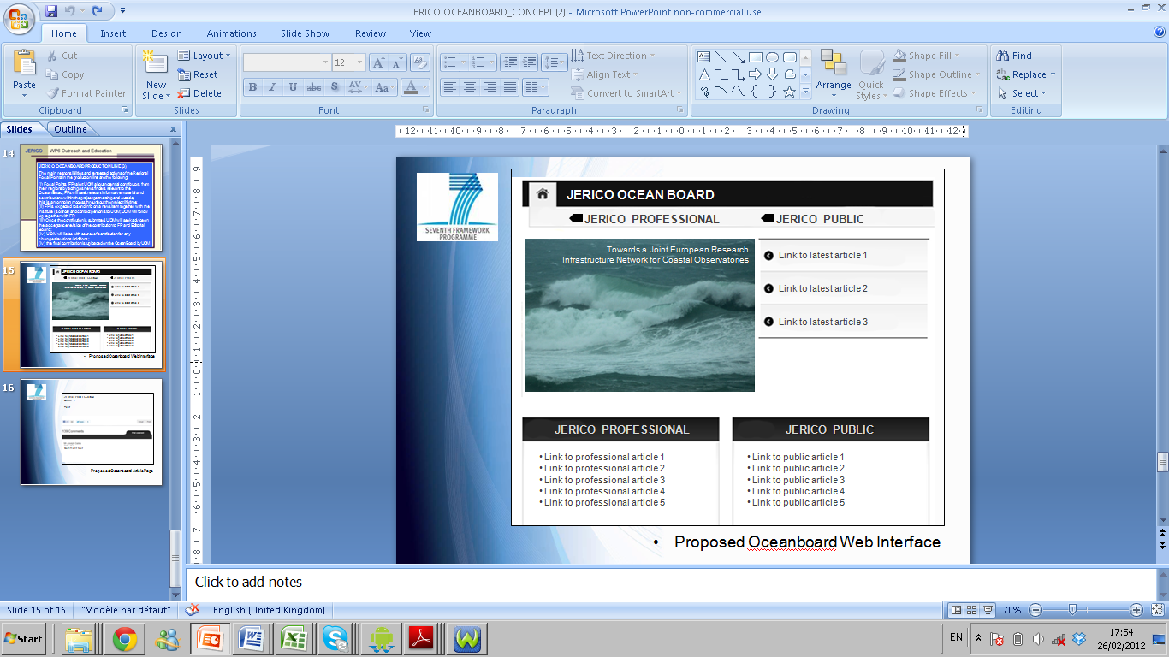

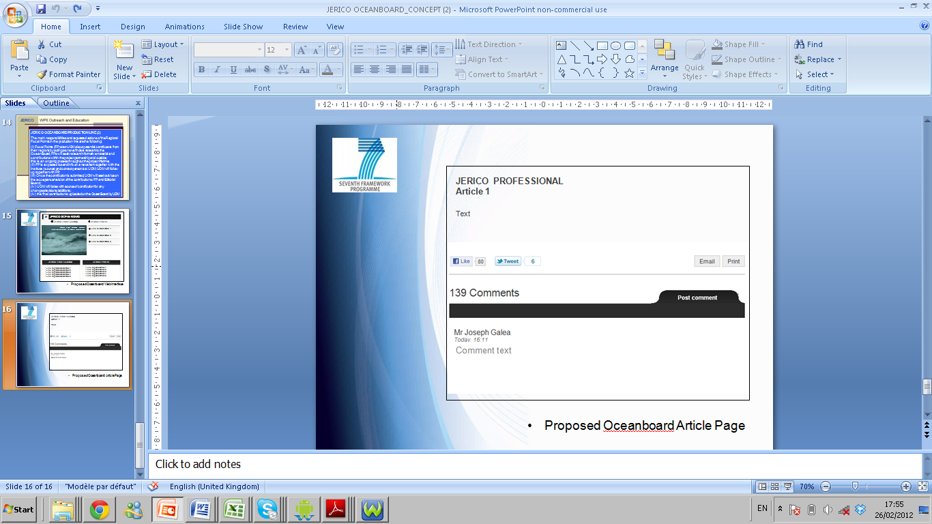
Actual Screenshots of implemented OceanBoard (beta version) in JERICO website
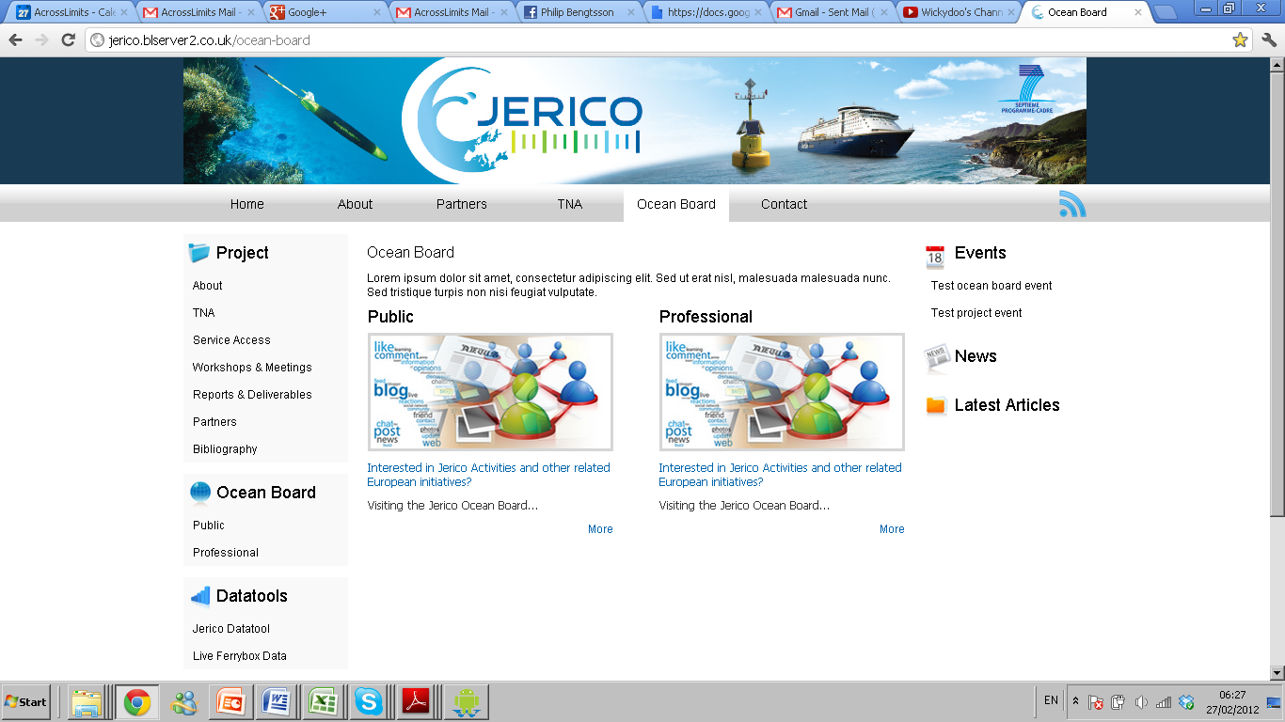

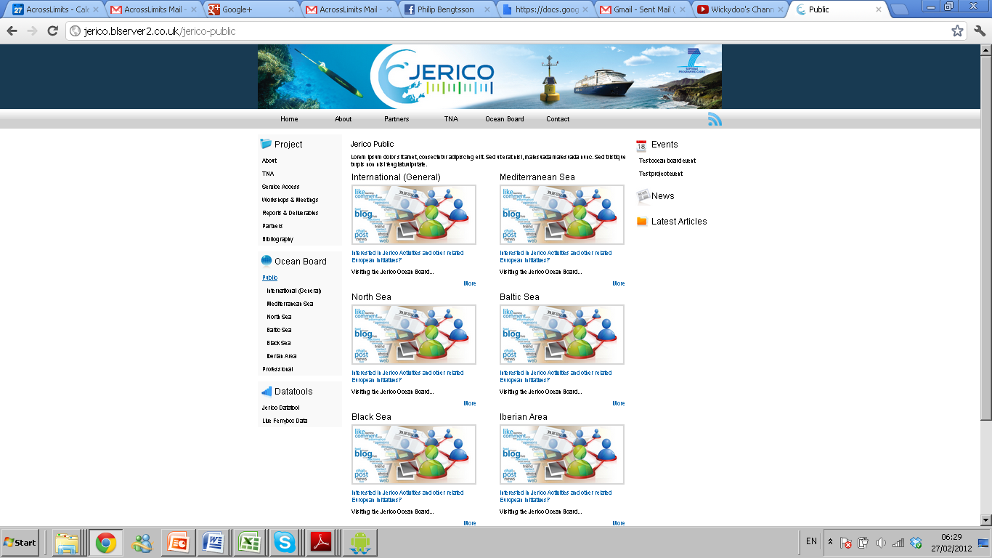

Update on Current Status - Content Development

With respect to the Editorial Board it has already started functioning and has made initial contact with the Focal Points in order to agree on a modus operandi.
Moreover several articles are already in the pipeline, and they focus on a variety of topics with respect to initiatives, public or private that could be of interest to the target audiences of the OceanBoard.
The first initial list of articles includes:
- What is Jerico
- European Environment Agency News
- Seafloor earthquake observatory
- Euromed conference
- SMOS Barcelona expert centre
- MyOcean
- EMODNET
- Global HF Radars
- Calypso Project

This list is constantly expanding and all topics will be placed according to whether they are for public or professional consumption and also then split by region.
The University of Malta and its team is taking a serious lead in this, and is motivating all other partners to give contributions for the OceanBoard.

