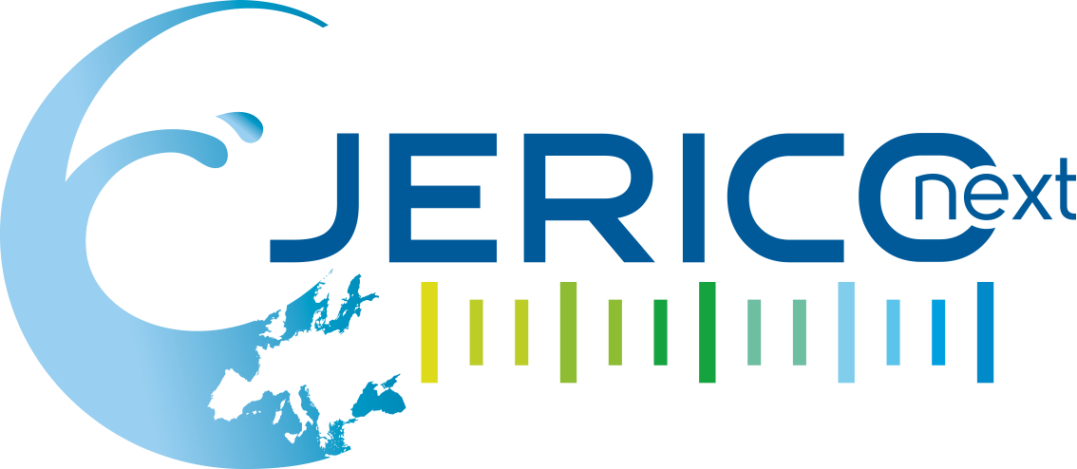

Joint European Research Infrastructure network for Coastal Observatory – Novel European eXpertise for coastal observaTories - JERICO-NEXT
Deliverable title |  | Template for assessment of Web based portals under JERICO-NEXT WP6.
Work Package Title |  | WP 8
Deliverable number |  | D8.12
Description |  | To communicate new scientific knowledge derived from JERICO-NEXT to maximise societal benefit in policy, research and operational (including industry) sectors and to promote uptake of Trans National and Virtual Access Services.  Template for reporting of periodic assessments of Virtual Access
Lead beneficiary |  | CEFAS
Lead Authors |  | Michelle Devlin (CEFAS)
Contributors |  | Simon Keeble (Blue Lobster)  Veronique Creach, Kate Collingridge, Michelle Devlin (CEFAS)  Sylvie Pichereau, Ingrid Puillat (Ifremer)  Antonio Novellino (ETT)  Nick O’Neill (SLR)
Submitted by |  | Dr Michelle Devlin (CEFAS)
Revision number |  | V1.0
Revision Date |  | 16/09/2016
Security |  | Public
History
Revision | Date |  | Modification | Author
0 | 16/05/2016 |  | First Drafting of document | Michelle Devlin
1 | 16/06/2016 |  | Revision of first draft of document | Aldo Drago
2 | 29/06/2016 |  | Revision of first draft of document  Further revisions  Contribution by partners | Kate Collingridge  Antonia Novellino  Simon Keeble  Sylvia Pichereau  Nick O’Neill
3 | 16/09/2016 |  | Finalisation of document | Michelle Devlin

Approvals
 | Name | Organisation | Date | Visa
Coordinator | Patrick Farcy | IFREMER | 26/06/2016 | PF
WP Leaders | Simon Keeble | Blue Lobster

.

PROPRIETARY RIGHTS STATEMENT
THIS DOCUMENT CONTAINS INFORMATION, WHICH IS PROPRIETARY TO THE JERICO-NEXT CONSORTIUM. NEITHER THIS DOCUMENT NOR THE INFORMATION CONTAINED HEREIN SHALL BE USED, DUPLICATED OR COMMUNICATED EXCEPT WITH THE PRIOR WRITTEN CONSENT OF THE JERICO-NEXT COORDINATOR.

Table of contents

Table of contents 4
1. Executive Summary 5
2. Introduction 6
3. Main report 8
3.1. Description of the modality of access under this proposal 8
3.2. Review procedure under this proposal 9
3.3. Reporting template for the assessment of virtual access sites 9
4. Conclusions 18
5. Annex A: Rules for providing virtual access to research infrastructure 19
6. Annex B: Information on direct personnel costs under JERICO-NEXT 21
7. Annex C: Description of the Virtual Access infrastructures 22
8. Annex D: Google analytics outputs 23

Executive Summary

This deliverable forms part of subtask WP8.9 which looks to coordinate the provision of access to Virtual Services identified through WP6. JERICO-NEXT will integrate a large number of research infrastructures through provision of both Trans-National Access to facilities and access to data and data services. Valorisation of data will be enhanced through a large number of virtual access services, including online software-based services providing harmonized analysis of ecological data. Uptake of information available through these virtual access services will be enhanced in JERICO-NEXT through expansion of the user community studying a broader set of coastal environment and ecosystems through increased collaboration, knowledge sharing and information uptake across a wider marine community.
The premise for this work under WP6, supported by activity under WP8, is that virtual access to resources needed for research should be available via an easy to use data system that can be accessed by all members of the European community as well as communities outside of Europe. Examples of virtual access activities are databases available via Internet, or data visualisation services. JERICO-NEXT will provide financial support to virtual services widely used by the community of European researchers.
The assessment of the VA services will be through collaborative discussions with the VA providers ensuring that the appropriate questions have been asked of the service. Funding under Jerico-Next for the virtual services has already been given to the VAI’s identified in the initial Jerico project. However, continued funding will be progressed after evidence of wide uptake and utility is demonstrated. Therefore, the services offered under each project will be periodically assessed by board consisting of select partners from the project consortium and external parties. In addition, statistics on the access provided shall be given to the Commission to provide periodic reporting on the wider uptake of these virtual access portals.
The final assessment will be through the VA services responding to a series of question (see Annex A) that will provide information on access activity, scientific and education output and integration of data to other data services. This report presents the background to the requirements for assessment of VA services and presents the questions that will be asked of the VA services.

Introduction

JERICO-NEXT is a Horizon 2020 project aiming to extend the EU network of coastal observations developed in JERICO (FP7) by adding new innovative infrastructures while integrating biogeochemical and biological observations. The main target of JERICO-NEXT is to provide continuous and more valuable coastal data coupling physical and biological information by further developing, harmonising and integrating nationally funded marine observing systems collecting physical, chemical and biological parameters from different platforms. It aims at providing researchers and other stakeholders with data that can sustain both innovative high-quality research, new knowledge supporting European directives, and business opportunities.

The JERICO-NEXT program is delivered across 33 organisations and will improve substantially the coordination and efficiency of coastal observing systems in EU regional seas. Work under WP6 is strongly linked to Networking Activities (NA) with objectives to sustain the JERICO-RI over the long term. There are currently 2 specific actions are identified to better identify and characterize end-users in WP6 and WP8. WP6 will offer virtual access to some JERICO data and dedicated services that will be assessed in terms of use and accessibility. WP8 will create a channel to promote JERICO infrastructure, results and services toward several end-user groups including public, policy, research, education and operational communities including industry. One objective is to better understand the requirements of the user groups and improve the effectiveness of communication strategies and increasing societal impact.

The primary objective of WP6 is to provide free of charge “virtual access” to data and information from systems such as HF radar, Ferrybox and fixed platforms. “Virtual Access means “access to resources needed for research through communication networks without selecting or even identifying the researchers to whom access to resources is provided. Examples of virtual access activities are databases available via Internet, or data deposition services. The data and information access will enable scientists to carry out high quality research using data from a variety of coastal observation systems. It will also promote the improvement of existing services and potentially the development of new services. Improvement of existing services may result from feedback from a variety of new users of services provided by the JERICO-NEXT programme. For example, access to in situ data can improve calibration and validation of numerical models and also provide sea truth data that improves the quality of information derived from remote sensing. New downstream services may result from users developing new data processing tools, systems and algorithms (e.g. development of algorithms for processing data from HF radars) in order to make best use of data derived from JERICO Virtual Services.

Only virtual services widely used by the community of European researchers will continue to be supported under Jerico-Next, and the services offered under a project shall be periodically assessed by an external board. As these services are already freely available, there is no need for a competitive selection of users and therefore no need to set up a selection panel. However, user identification may still be necessary as part of virtual access when this is subject to specific requirements such as registration, authentication and/or authorisation of users (e.g. for access to sensitive data). The access provider will need to publicise widely the access offered and to agree on a set of questions that will provide a template for the periodic assessment of the services offered, as only virtual services widely used by the community of European researchers would continue to be supported. This work package (WP6) will, in collaboration with the VAI providers, report on the value of the VAI, the evidence of the existing client community and their continuing needs for the particular scientific services offered by the VAIs. This information will be of value in order to prioritise and promote the future development of the JERICO network.

Virtual access activities have been supported through
(a) the reimbursement of a proportion of the operating costs related to data access provision. Note that only costs related to provision of the VA service may be included. So quality control of data, development of products, server costs etc, but not costs related to collecting the data and operating the platform (Annex C).
(b) installation for providing virtual access to resources over the duration of the project.
Virtual access are supported through the reimbursement of the eligible costs that can be clearly attributed to the provision of the access and have been incurred over the duration of the project.

- The cost must not be covered by other EU funds. When they are covered by other non-EU founding sources specifically provided to support them, these funds must be declared.
- Provision of greater access to the platform and data will provide a good pathway to reimbursement
- Provide examples of “unlocking” and “connecting” the data accessed through the VAI

EU financial support will never include capital investments, however, it may cover technological and scientific support needed by researchers to effectively use the virtual access service. Only eligible costs that can be clearly attributed to the provision of access can be reimbursed.
There are rules around the provision of access. The access must be free of charge with virtual access’ meaning open and free access through communication networks to resources needed for research. The access provider must have the virtual access services assessed periodically by a board composed of international experts in the field, at least half of whom must be independent from the beneficiaries. Virtual services will only be supported if evidence of wide uptake and utility is demonstrated. Therefore, the services offered under a project shall be periodically assessed by board consisting of select partners from the project consortium and external parties. The assessment report must be provided to the EC together with statistics on the access offered during the project, e.g. quantity, geographical distribution of users and, when possible, information/statistics on scientific outcomes acknowledging the use of the infrastructure (publications, patents, etc.).
The rules around the provision of access are set out in Annex A.

Further information on the description of personal costs for providing trans-national or virtual access to research infrastructure under H2020 is provided in Annex B.

Main report

Description of the VA services
The scale of the funding that has been allocated based on the type and scale of the operational costs relative to the portal. Typically, the services will already be widely used. VA services currently funded are listed in Table 1. A full description of the participating VA services is further presented in Annex C.

Table 1: List of participating VA services currently funded under Jerico-Next.
ROOS | Name of Service | Description of Service
Arctic | NorFerry | NorFerry
NOOS | COSYNA | COSYNA
NOOS | EMECO | EMECO
BOOS | Utö | Utö Atmospheric and Marine Research Station
BOOS | MOS | SMHI Marine Observation System
BOOS | SYKE-Alg@line | SYKE Marine Research Centre
BOOS | NIVA Research Station (NRS) | NIVA Research Station (NRS)
MEDGOOS | LiSO-HFR | LiSO-HFR
MEDGOOS | POSEIDON | Monitoring, forecasting, information system for Greek Seas
MEDGOOS | SOCIB Data Centre Multi Platform Observatory | SOCIB Data Centre Multi Platform Observatory
MEDGOOS | Environmental Observable Littoral | Environmental Observable Littoral
Black Sea | NOMOS | National Operational Marine Observing System
IBIROOS | BHFR | BHFR
IBIROOS | SPI-S | SPI-S
IBIROOS | MONICAN | Monitoring of Nazare Canyon network
IBIROOS | Eulerian observatory network data service | Eulerian observatory network data service

Eligible costs can be claimed as long as VA services were made available as described in the GA and clearly advertised,. VA services which are not considered appropriate by the assessment board will be discussed within the Consortium and with the EC and in particular which actions could be taken. These actions can include better advertisement, improvement of services or removal from the VA (in such case an amendment would be necessary). However, in case no action is considered in due time, these costs would be deemed not necessary and become not eligible.

- A user will access an infrastructure listed in the WP remotely via the internet to gain access to a service that delivers data or information. Only remote of access is provided:
- Access can be shared simultaneously with more than one user. EU financial support to virtual access will cover the costs incurred by the access provider for the provision of access to the infrastructure.
- Unit of access (UA): The access will be quantified by its minimum duration which will typically be the period required to gain access to the service (e.g. via a web site) and carrying out the steps required to access the data or information required. A UA may range from minutes to a few days or more.
- Outreach to new users: Virtual Services to be offered will be publicised on the JERICO-NEXT web site.. In addition, providers of Virtual Services can carry out their own outreach activities that include; improving visualisation of data and information, making data more easily accessible, publicising VA at meetings, broadcasting information through professional networks (e.g.EuroGOOS Regional Observing Systems, EMODnet portals) and highlighting topical aspects of potential services (e.g. trans-boundary data sets).
- Access to Virtual Services will be via the established web links. However, the disparate services will be grouped based on the EuroGOOS ROOS (Regional Operational Oceanographic Systems) regions. The ROOS portals will provide links to those Virtual Access services in their region.

Review procedure under this proposal
Periodic annual assessment of the virtual access activities will be carried out in WP8 (T8.9). A template has been developed (see Table 2, 3, 4, 5) to gather appropriate information around the VA services including statistics around access, activity, scientific influence and communication. Reports submitted by the VAI’s will be reviewed by an appointed panel of partners and external parties and assessed through that panel. The panel will be developed around the user engagement board as set up under Task 8.1EC.

Reporting template for the assessment of virtual access sites
The Web based portals identified under JERICO-NEXT have been selected for funding under the JERICO-NEXT remit to support the dissemination of web based, easily accessed information for European waters.

Whilst the value of all the VA services are recognised and are a key component in the delivery of a European wide observatory network, they will be assessed and reported using four main sets of evaluation criteria. The reports must detail the access activity, with statistics on the virtual access provided in the period, including quantity, geographical distribution of users and, whenever possible, information/statistics on scientific outcomes (publications, patents, etc.) whilst acknowledging the use of the infrastructure (Table 2)

Table 2:Summary of evaluation criteria for the assessment of VA services.

Evaluation criteria | Description | Score
i | Assessment based on the quantity and diversity of the web based traffic. | 30
ii | Assessment based on the utility of the data and how the data is used across European and international frameworks. | 25
iii | Assessment based on the scientific and educational value of the data. | 25
iv | Assessment based on the integration of data services reported under the VAI | 20

Virtual access sites will be assessed through a series of questions that test the utility and the type of access around the VA sites. This utility is examined in a series of questions over four sets of evaluation criteria. The questions will focus on the access statistics (Table 3), the influence of the data at a European and international level (Table 4), the access and uptake of data into scientific, government and education processes (Table 5) and the integration of the data into further data services (Table 6).

The first set of evaluation criteria (i) reflects the information on the data usage around the website. Statistics on usage would include:
- Repeat visitors over the period
- Average length of time per visit
- Locations of enquirers, by country/continent
The preferred means for providing the basic statistical information are for all participating institutions to have Google Analytics enabled on their websites. They provide details of their Google Analytics accounts, permitting Cefas to collect statistics on their behalf and aggregate and publish them as required (Table 3). Annex D presents an example of the type of outputs collected by Google Analytics, but is shown only as an example of the type of data collected under this criterion.

The second set of evaluation criteria (ii) will focus on where the data goes, who is using it, and what other internal or external functions are improved or elevated due to the information contained on the website. Examples will include data being accessed by national and international modelling processes, validation of earth observation data and inputs into European data streams. The access provider will still need to publicise widely the access offered and report on the success of the publication and communication of data (Table 4).

The third set of evaluation criteria (iii) will focus on the input of the VA site into scientific and general knowledge processes. This will be measured by a quantitative assessment of science and data publications which have been associated with the data and information held in the website and a semi-quantitative assessment of science activity, including presentations across government and end-users, participation in national and international programs and links into educational programmes (Table 5).

The last criterion (iv) will focus on the capability of the VAI to integrate new data and services to increase the level of the quality of the provided data and services. This will be measured by a quantitative assessment of the datasets/platforms/services. Examples will include data inputs into European data streams (examples include but not limited to, EMODnet, ROOSes, ICES) and will rely on “integrators ” giving periodic feedback. Integrators can report on how much data is provided in terms of parameters, datasets, and new data (Table 6).

For criterion (iv),we will customise the rules of assessment in collaboration with VAIs. For example, if the VAI is operating on several platforms, the questions around the fourth criterion may focus on the availability of (open and free) historical data and the ability to link across platforms. If the VAI was mainly delivering access to Ferrybox data, the questions around the fourth criterion would ask for provision of information about the data collected from that ferry. This could focus on detailing any historical gaps and provide near real time and delayed mode as soon as possible. Timing in the provision of data could also be an indicator.

Table 3: Assessment on traffic associated with the Virtual Access data.
Q1 | Are you prepared to allow external assessors to access your Google Analytics account, to extract statistics on your behalf?  (if a Google Analytics account is not in use, would you be prepared to add the required HTML script to enable this reporting?) | Y
If Q1 is ‘N’ | Will you provide the required statistics directly into an agreed template | Monthly  or  Quarterly
 | Will you deliver required statistics by? | Email  or  FTP
Q2 | Can you provide estimates for the following questions around data usage on your website?
Q2.1 | How many unique visits per month / year
Q2.2 | How many repeat visits per month / year
Q2.3 | What was the average length of time per visit?
Q2.4 | Can you provide a summary of locations of enquirers, by country and continent
Q2.5 | Can you provide information on the number of data downloads?
Q2.6 | Can you provide information on the most frequent enquiries associated with your web pages
Q3 | Please provide a details of a contact who will work with Cefas

Table 4: Assessment on the influence of data across European and international programs and the impact of data on business activity.
Q 1 | Can you describe the scope of users who access the data portal? Please include science, managers, policy and industry end-users.
Q 2 | Can you describe (and give examples where appropriate) of the type of products that have been created, developed or improved through access to data from your web-site
Q 3 | Can you describe (and give examples where appropriate) the processes that have been informed by data accessed through your website. This can include validation of physical and biological modelling and validation of Earth Observation data.
Q 4 | Can you describe (and give examples where appropriate) links to other processes, portals and websites that are using data supplied via access to your virtual data. Examples would include EMODnet, ICES, and other European and international programs and data infrastructures. If possible, provide a catalogue of the VAI/virtual data offered, so can be included into the automatic reports and we can see if they are able to add new data/products into these VAIs

Table 5: Influence of data and information on scientific and educational endeavours. Assessment on the influence of data and information from the virtual access site on scientific endeavours.

Q 1 | Can you detail the number of data publications (with DOI if possible) associated with data accessed through the VA site. It is preferable to make the distinction between in-house (within institute) publications and external publication from people outside the institute that have utilised data within the publication.
Q 2 | Can you detail the number of research publications and the citation rate associated with those publications which have been informed by data accessed through the VA site. This can include any type of research publications in any science discipline.
Q 3 | Can you detail the number (if possible) of presentations across Europe and international agencies which have been informed by data accessed through the VA site? It is recognised it may be difficult to document all presentations that may have used data from the VA site, so a qualitative description of types of presentations, and the scope of the audience and the organisations involved is sufficient. Please provide as comprehensive list of presentations as possible (type of information could include name of workshop, session, conference, plenary etc)
Q 4 | Can you provide a summary of the end-users that have been informed by data accessed through your site? This can include any additional communication processes or products that have been developed to inform a wider community including fact sheets, report cards, undergraduate and post-graduate courses, NGO’s, concerned community representatives, and government agencies.
Q5 | Please provide any other information showcase the value of the VA site. Please comment and list any media interactions and communication products. Please also list cross links to other VAI and integrators.

Table 6: Assessment based on the integration of data and new services added to the VAI
Q 1 | Assessment criteria to be developed in consultation with the VAI, and dependent on the type of portal and the type of data access offered.  Questions to be developed with VIA providers on specific attributes of each site.

Conclusions

This program will support European coastal research communities by sharing existing networked observatories. This objective will be achieved, in part, by providing services (such as easy access to data and tools) through the Virtual Access activities and to create a step change in the observing system performance by integrating innovative sensors and instruments developed in Europe. Task 8.9 will report on the information within the virtual access portals and provide a mechanism for evaluating the accessibility and utility of each virtual access service. This information will be of value in order to prioritise and promote the future development of the JERICO network. The reports must detail the access activity, with statistics on the virtual access provided in the period, including quantity, geographical distribution of users and, whenever possible, information/statistics on scientific outcomes (publications, patents, etc.) whilst acknowledging the use of the infrastructure.

Annex A: Rules for providing virtual access to research infrastructure
Access providers must provide access to research infrastructure or installations in accordance with the following conditions:

(a) Access which must be provided: The access must be free of charge, virtual access to research infrastructure or installations. ‘Virtual access’ means open and free access through communication networks to resources needed for research, without selecting the researchers to whom access is provided;

(b) Other conditions: The access provider must have the virtual access services assessed periodically by a board composed of international experts in the field, at least half of whom must be independent from the beneficiaries.

Consequences of non-compliance

If a beneficiary breach any of its obligations under Articles 16.1.1 and 16.2, the costs of access will be ineligible (see Article 6) and will be rejected (see Article 42).
If a beneficiary breach any of its obligations under Articles 16.1.2, the grant may be reduced (see Article 43).
Such breaches may also lead to any of the other measures described in Chapter 6.]

Access provider’ means a beneficiary or linked third party that is in charge of providing access to one or more research infrastructures or installations, or part of them, as described in Annex 1.
Installation’ means a part or a service of a research infrastructure that could be used independently from the rest. A research infrastructure consists of one or more installations.

Virtual access to research infrastructure
This optional Article (together with the corresponding options in Article 6 and other provisions) will be inserted into the GA if the action involves virtual access to research infrastructure for scientific communities (‘provision of access activities’), i.e.:
actions under Part I of the Horizon 2020 Framework Programme, ‘Research infrastructures’.

H2020 grants will only support virtual services that are widely used by the community of European researchers.
Grants for this type of actions usually cover — for the provision of access activity — the following types of costs:
- operating costs of the installation during the course of the action
- costs related to technological and scientific support for users’ access (e.g. a helpdesk)
- costs of advertising virtual access offered under the action
- costs related to the assessment carried out by the board of international experts (e.g. costs of organising a board meeting)
- costs of preparing the detailed access activity information that must be included in the periodic technical reports and the assessment report

Capital investments (i.e. costs of renting, leasing, purchasing depreciable equipment, infrastructure or other assets) will not be reimbursed (for the provision of access activity

Virtual access quantity can in principle NOT be measured; therefore, the GA does not specify a unit of access for virtual access provision.

The beneficiaries must include detailed information on the provision of access activity in the periodic technical reports, in the form of statistics on all users in the reporting period compiled through web analytical tools.

Additional condition for eligibility: Access which must be provided
Virtual access applies to widely-used research resources that are openly and freely available through communication networks. Example: access to an open database available on the internet.
Access must be open to all users; users are not selected.

Additional condition for eligibility: Periodic assessment by a board of international experts
For virtual access, the access services must be regularly assessed by an external board of international experts.
At least two assessments are usually carried out during the course of an action.
The assessment reports must already be part of the proposal (as deliverables; see the proposal templates) and be included in Annex 1 of the GA.

Annex B: Information on direct personnel costs under JERICO-NEXT

Available at http://ec.europa.eu/research/participants/data/ref/h2020/other/legal/unit_costs/unit-costs_sme-owners_natural-persons-no-salary_en.pdf

Available at http://ec.europa.eu/research/participants/portal/desktop/en/funding/reference_docs.html#h2020-work-programmes.

The total number of hours declared in EU and Euratom grants for an SME owner for a year (i.e. a financial year) can NOT be higher than the standard number of annual productive hours used for the calculation of the hourly rate (i.e. 1 720 hours).

Direct personnel costs: Personnel costs for providing trans-national or virtual access to research infrastructure
1.5.1. This budget category covers the personnel costs for access to infrastructure activities, i.e.: H2020 AGA — Annotated Model Grant Agreement: V2.1 – 30 October 2015 General MGA
72
- costs for employees (or equivalent)
- basic remuneration and
- for non-profit legal entities: additional remuneration
- costs for natural persons working under a direct contract and
- costs of personnel seconded by a third party against payment.

1.5.2 Personnel costs for providing trans-national or virtual access to research infrastructure may be declared as actual costs or on the basis of unit costs in accordance with the usual cost accounting practices (i.e. ‘average personnel costs’) (see Article 5.2(a)).
1.5.3 The costs must comply with the following conditions for eligibility:

- fulfil the general conditions for costs to be eligible (i.e. incurred/used during the action duration, necessary, linked to the action, etc.; see Article 6.1(a) and (b))
- fulfil the specific conditions for costs for employees (or equivalent), costs for natural persons working under a direct contract or costs of personnel seconded by a third party against payment
- be incurred for providing trans-national or virtual access to research infrastructure
- fulfil the additional cost eligibility conditions set out in Article 16.1 or 16.2.

1.5.4 The same rules for cost calculation apply as in points 1.1.4, 1.2.4 and 1.3.4.

Annex C: Description of the Virtual Access infrastructures
ROOS |  | Service name | Institute | Contact name | Contact email | Location | Web address | Annual operating costs
Arctic | NorFerry | NorFerry | NIVA | Kai Sorensen | kai.sorensen@niva.no | Baltic, North Sea, Atlantic Sea and Arctic areas. | http://www.niva.no | €220,000.00
NOOS | COSYNA | COSYNA | HZG | Willi Petersen | wilhelm.petersen@hzg.de | North Sea | htto://www.cosyna.de | €168,212.50
NOOS | EMECO | EMECO | CEFAS | Eva Garnacho | Eva.garnacho@cefas.co.uk | Lowestoft, UK | http://www.jerico-fp7.eu/datatool/ | €130,000.00
BOOS | Utö | Utö Atmospheric and Marine Research Station | FMI | Lauri Laakso | Lauri.Laakso@fmi.fi | Baltic Sea; Archipelago Sea, Island of Utö | en.ilmatieteenlaitos.fi/uto | €150,262.50
BOOS | MOS | SMHI Marine Observation System | SMHI | Bengt Karlson | Bengt.Karlson@smhi.se | Gothenburg and Norrköping, Sweden | www.smhi.se | €13,125.00
BOOS | SYKE-Alg@line | SYKE Marine Research Centre | SYKE | Jukka Seppala | jukka.seppala@ymparisto.fi | BOOS. Baltic Sea – Helsinki, Finland -Germany; Stockholm,SW | http://www.itameriportaali.fi/en/tietoa/algaline_seuranta/en_GB/algaline_seuranta/ | €68,625.00
BOOS | NIVA Research Station (NRS) | NIVA Research Station (NRS) | NIVA | Kai Sorensen | kai.sorensen@niva.no | Oslofjord, Norway. | www.niva.no | 45000
MEDGOOS | LiSO-HFR | LiSO-HFR | CNR-ISMAR | Annalisa GriffaMarcello Magaldi | annalisa.griffa@sp.ismar.cnr.it; marcello.magaldi@sp.ismar.cnr.it | Ligurian Sea | http://radarhf.ismar.cnr.it | €87,500.00
MEDGOOS | POSEIDON | Monitoring, forecasting, information system for Greek Seas | HCMR | Leonidas Perivoliotis | annalisa.griffa@sp.ismar.cnr.it; marcello.magaldi@sp.ismar.cnr.it | Aegean Sea, Cretan Sea | http://poseidon.hcmr.gr/ | €87,375.00
MEDGOOS | SOCIB Data Centre Multi Platform Observatory | SOCIB Data Centre Multi Platform Observatory | SOCIB | Joaquim Tintore | jtintore@socib.es | Balearic Islands | www.socib.es | €100,000.00
MEDGOOS | Environmental Observable Littoral | Environmental Observable Littoral | CNRS | Laure Mousseau | laure.mousseau@obs-vlfr.fr | Ligurian Sea | http://www.obs-vlfr.fr/Innovations/EOL/ | €70,781.25
Black Sea | NOMOS | National Operational Marine Observing System | IO-BAS |  | palazov@io-bas.bg | Western Black Sea | http://www.bgodc.is-bas.bg | €270,000.00
IBIROOS | BHFR | BHFR | AZTI | Julien Mader | jmader@azti.es | SE Bay of Biscay | http://www.euskalmet.euskadi.net/s075853x/es/meteorologia/selsensorR.apl?e=5&cod_esta=R096 | €29,033.36
IBIROOS | SPI-S | SPI-S | CNRS | Antoine Grémare <a.gremare@epoc.u-bordeaux1.fr> | a.gremare@epoc.u-bordeaux1.fr | Arcachon, France | http://spiarcbase.epoc.u-bordeaux1.fr/ | €65,000.00
IBIROOS | MONICAN | Monitoring of Nazare Canyon network | IH | Joao Vitorino | joao.vitorino@hidrografico.pt | Nazare, Portugal | http://monican.hidrografico.pt/ | €61,308.60
IBIROOS | Eulerian observatory network data service | Eulerian observatory network data service | Ifremer | Guillaume Charria | guillaume.charria@ifremer.fr | Brest, France | http://www.coriolis.eu.org/Data-Services-Products/View-Download/Eulerian-networks-fixed-buoys | €139,058.75

Annex D: Google analytics outputs

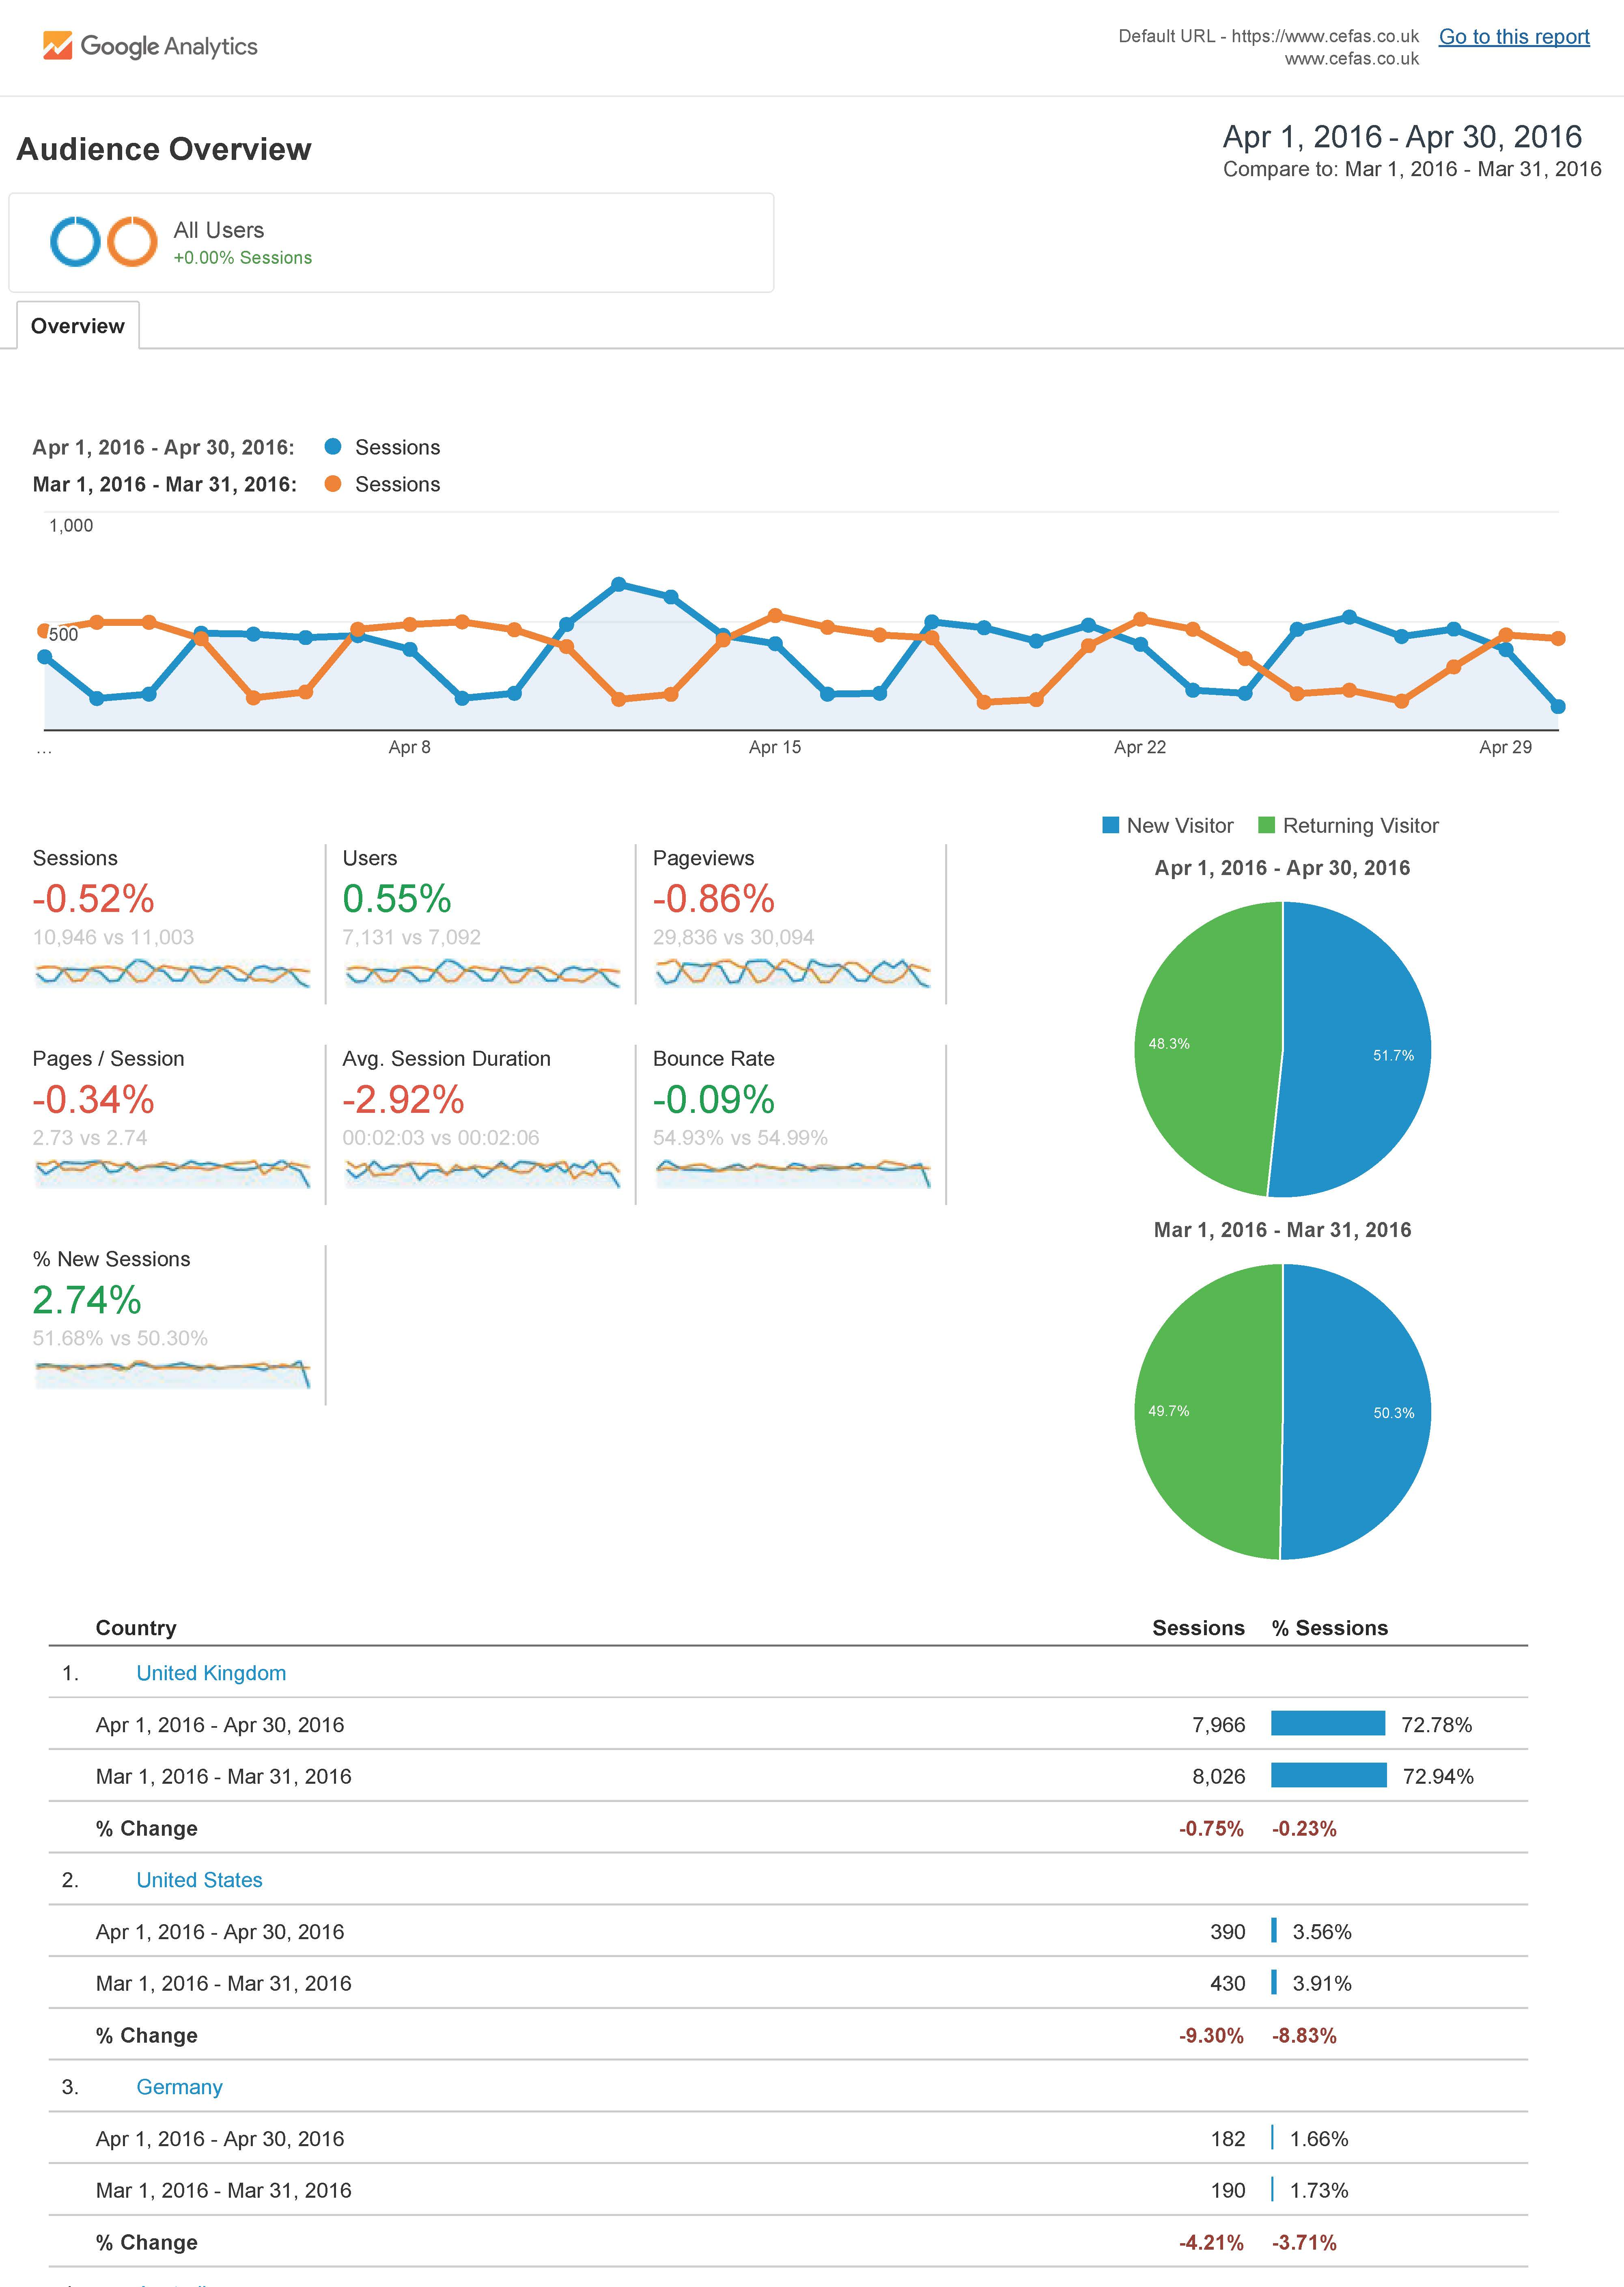

The board of international experts in the field will be set up by the JERICO-NEXT consortium. It is required that at least half of them are independent from the beneficiaries. The external experts can be members of other JERICO-NEXT external boards. An independent project review is however foreseen by the Commission, not restricted to the VA.“
www.emodnet-physics.eu/map/dashboard can provide an automatic service that sends a subset to you periodically. It would be useful to promote the access to the platform/data via the EMODnet platform page (it has a unique url)
Integrators can be any individual or organisation that is regularly accessing data from the VA service into a further data service.
Only costs related to provision of the VA service may be included. So quality control of data, development of products, server costs etc, but not costs related to collecting the data and operating the platform.

