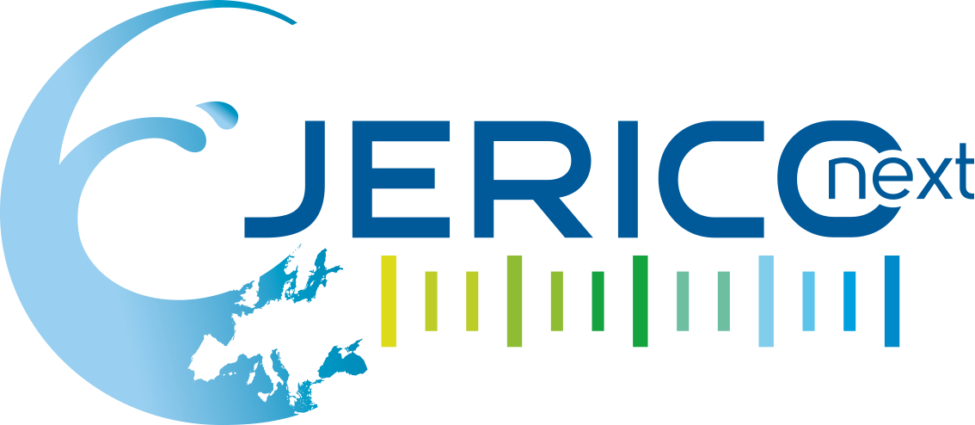

FIRST MEETING OF THE USER PANEL

Helsinki, March 14th, 2017
Session Follow Up Document

The JERICO-RI aims to integrate key autonomously operating coastal observatories in Europe, by addressing their future within a shared pan-European framework that will enhance harmonization, performance and sustainability at the transnational level. It aims to provide a common, transparent platform for the identification and dissemination of best practices for the design, implementation and maintenance of such observatories, and will contribute to the definition of data quality and dissemination standards for coastal data.

The aim of WP8 is to increase understanding of the importance and maximise the impact of JERICO-NEXT research for targeted end-users across policy, industry, science and educational sectors and the wider public and to promote uptake of JERICO-NEXT Services for Trans National and Virtual Access.

This document summarises the discussions of each session during the User Panel (UP) Workshop that was organised in Helsinki on the 14th of March 2017.

Session 0 - Introduction
Simon Keeble, WP8 Leader

Simon Keeble welcomed everyone and introduced Jo Foden from OSPAR who was acting as the chair of the JERICO-NEXT User Panel, Veronique Creach from CEFAS as the financial officer, and Adam Gauci from the University of Malta, leader of the task, acting as a secretariat for the User Panel. Prof. Aldo Drago from the University of Malta sent his apologies for not being able to be present.

It was made clear to the panel members that they were free to talk and express their opinions on the issues to be discussed. Simon also informed that all presentations would be made available on the website as well as a working plan that would allow the members of the User Panel to continue working as a group (or sub-groups) in the following weeks.

A round table was carried out where everyone introduced themselves, their affiliation and gave a brief overview of his/her work and areas of expertise. The people present in the meeting are listed in the table below. Apologies were received from Peter McKenzie-Midlane from Scitus Management Ltd, Michel André from Technical University of Catalonia, Svetlana Rusanovschi from ECOLAGUNA and Rodney Forster from University of Hull from the user panel. Other people from the JERICO-NEXT consortium attended throughout the day.

First name / Last name | Organisation | Role
Laurent Coppola | CNRS | User Panel Member
Olaf Sveggen | Fugro Norway A.S | User Panel Member
Johan Vercruysse | Flemish government -  MDK -aKust | User Panel Member
Bill Turrell | Marine Scotland | User Panel Member
David Mills | Bangor University | User Panel Member
Antoine Mangin | ACRI-HE | User Panel Member
Jo Foden | OSPAR | User Panel Member
Simon Keeble | Blue Lobster | Project Partner WP8 Leader
Veronique Creach | Cefas | Project Partner WP6 Leader
Stefania Sparnocchia | CNR ISMAR | Project Partner WP7 Leader
Dominique Durand | COVARTEC | Project Partner WP1 Leader
Adam Gauci | University of Malta | Project Partner
Sylvie Pichereau | Ifremer | Project Partner
Nick O'Neill | SLR Consulting | Project Partner
Emma Heslop | SOCIB | Project Partner
Patrick Farcy | IFREMER | Lead Project Partner
Didier Mallarino | CNRS | Project Partner
Glenn Nolan | EuroGOOS AISBL | Project Partner
Paul Gaughan | Irish Marine Institute | Project Partner
Anouk Blauw | Deltares | Project Partner

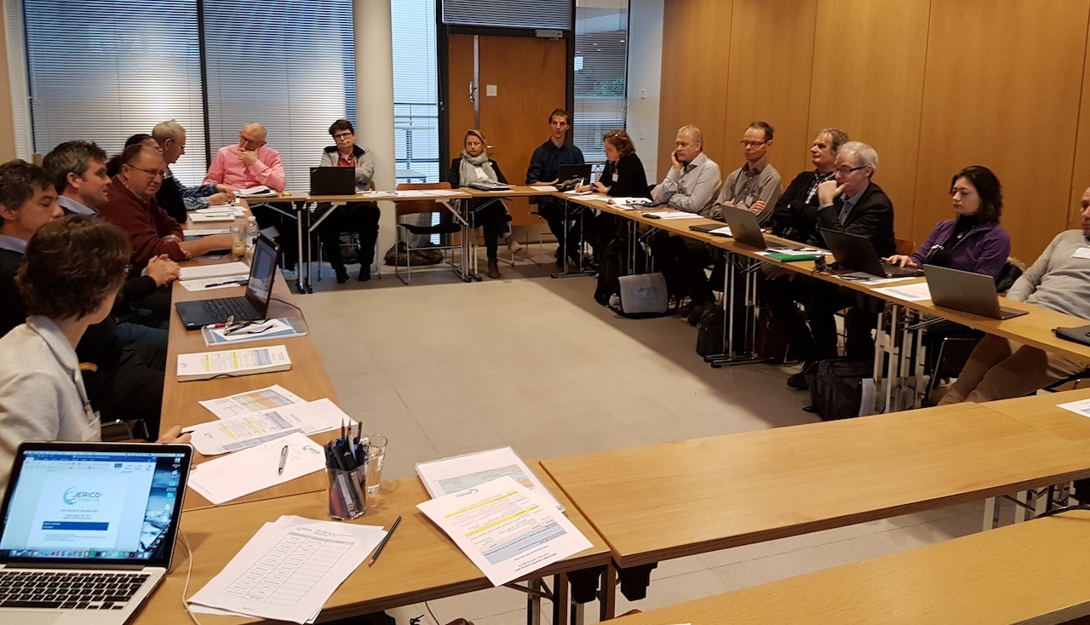

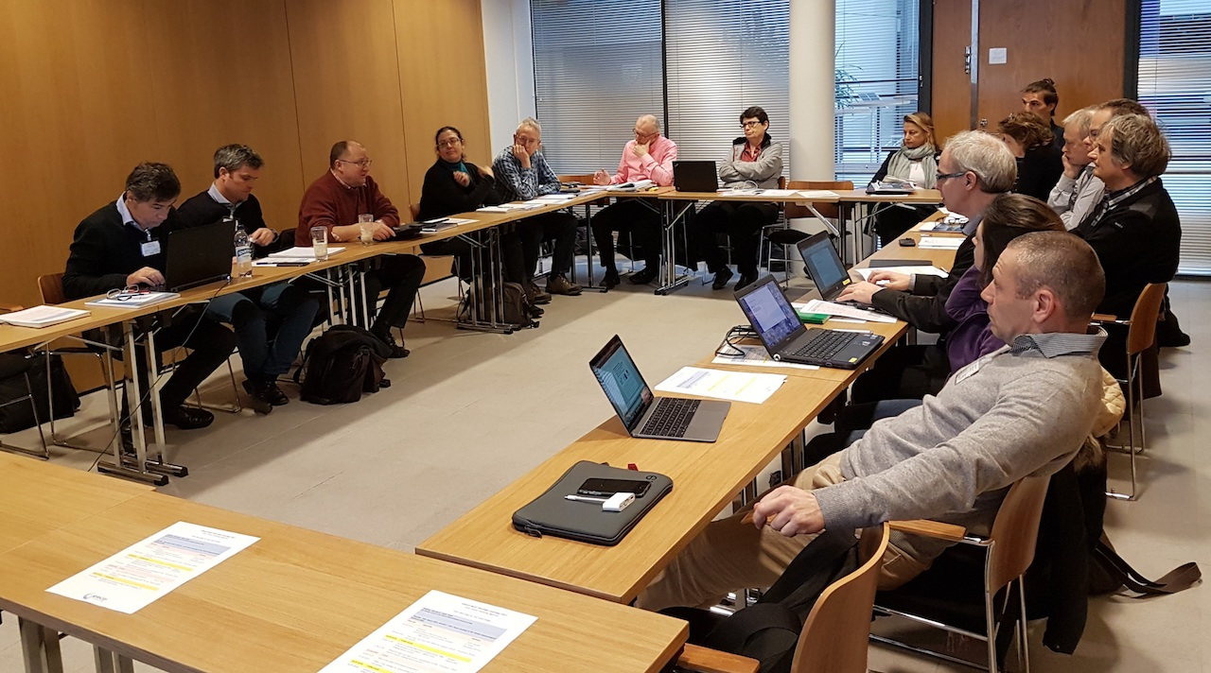

Session 1 - How does and how will JERICO-NEXT
support science and society?
Dominique Durand, WP1 leader

Dominique Durand explained that the main aim of JERICO-NEXT is to jointly carry out European research on coastal observations. There are a number of initiatives and projects in place that take care of observations from the bottom of the ocean, for example:
- ERIC is a legal European entity that targets to create a legal framework for communities related to research infrastructure. The main aim is to create the tools for a long-lasting synergy.
- FixO3 is an open water based research initiative.
- EURO ARGO, GROOM and EUROFLEET take care of open water observations.
- JERICO-NEXT that mainly deals with the coastal ocean.

JERICO-NEXT tries to sustain infrastructures in order to support sustainable environmental assessments and provide downstream services.
When JERICO was designed, it considered physical and chemical data. The current JERICO-NEXT project is also developing interactions with the biological community.

Antoine Mangin pointed out that it is important that the coastal observatories are supporting other means of observations such as remote sensing. In his field of expertise (Earth observation), there is a need for sustainable datasets at high resolutions, such as chlorophyll or suspended particulate matter on the coast, for example. His suggestion is to plan the in-situ measurements in order to feed different needs and combine different approaches for a better assessment of the environment. For example, to combine satellite data with models and in-situ validation so that they are not three independent type of observations anymore.

Patrick Farcy replied that JERICO-NEXT has to provide coastal sea data. In JERICO-NEXT, the main focus is in-situ data. Satellite data are needed for sea surface parameters. The new altimeter instruments should be able to provide data closer to the coast better. JERICO-NEXT is also trying to understand phytoplankton. The JERICO-NEXT is not to provide the sustainability aspect because most of the infrastructures involved in the project are sustainable. All the open ocean systems may be soon integrated into EOOS.

The first JERICO project started in 2011 and the focus was on physical data. The same core community was expanded to include biological parameters to better understand the functioning of the coastal areas. In JERICO-NEXT project, the network of infrastructures increased from 21 partners to 34. The complexity of the coastal ocean cannot be understood if the coupling between physics, biogeochemistry and biology is not understood. JERICO-NEXT aims to have an infrastructure that contributes to this kind of knowledge. JERICO-NEXT also wants to add new technologies that will contribute to this.

JERICO-NEXT is addressing pelagic biodiversity, occurrence of chemical contaminates, hydrography and transport, carbon fluxes, carbon systems, and also operational oceanography. This project also looks at how to address the societal challenges.

The quality controlled data from JERICO-NEXT are open access and available from the partner website, from the virtual access activity of the project and from European data portals (EMODnet and COPERNICUS). They support policy/directives, ocean forecasting, downstream services, and information services. Interested parties will then use the available infrastructure for research. Dominique pointed out that this is exactly what should be discussed with the User Panel – how to make possible this ‘value creation’.

The project wants to be useful to the research community, organisations in charge of the national monitoring as well as the private sector (industry, small and medium companies). The JERICO-NEXT infrastructure will deliver high quality data in a homogenised format to be found in data portal such as Copernicus or EMODNET.

JERICO-NEXT also should improve the capability to increase policy-related knowledge. JERICO-NEXT has to develop new sensors for investigating the biological and chemical components (based on nutrients, optical sensors, carbonate systems) and to integrate platforms and technologies (such as ferryboxes, gliders, fixed platforms, HF-radars, cabled-coastal observatories, coastal profilers, etc.). In terms of services to international regulating bodies, JERICO-NEXT can contribute by identifying the gaps and recommending how the JERICO-NEXT infrastructure can fill in these gaps.

In upstream services JERICO-NEXT has the technology providers who do research and develop new sensors. New sensors are tested to find how these can be integrated into existing systems. Comparisons and inter-calibrations of sensors are also carried out to make sure that data between different instruments are comparable. An aim is to have more technology providers that make use of transnational access (TNA) and to make this work in practice. On the other hand, for the downstream services, JERICO-NEXT would like small-medium sized enterprises (SMEs) to provide high value information, harmonise multidisciplinary data sets that are compatible with other marine data sources, and make this available for businesses to be developed further. This is the role of the Virtual Access Service.

Questions and comments from the user panel:
- Definition of biological data (Laurent Coppola)
- Lack of good equipment from Europe (e.g.: CTDs) compared to US (Olaf Sveggen). Action for JERICO-NEXT: list of equipment and their performance.

Veronique CREACH said that one of the products of Work Package (WP) 2 is to work and check the variability of different sensors. There is a lack of sensors to measure phosphate that can be mounted on a buoy. There are few people working with phosphates.

Antoine Mangin said that it impossible to mix in-situ data, modelled data, and data from new generation sensors. It is very difficult to generate harmonised and consistent data sets.

Stefania Sparnocchia said that WP5 considers all kinds of sensors. Antoine Mangin said that currently, sensors are rated from Class 1 (best quality data) to Class 4 (not so good data). But even the quality and range of Class 1 sensors might be different. Therefore, merging the data is not possible.

When you have data coming from different technologies and instruments that are not calibrated in the same way, it was important to know the uncertainties.

Antoine Mangin pointed out that it is important to make the people in European policy aware of how accurate the data are. They need to be aware about quality of data, and to avoid raising false alarms by providing margins of errors and probabilistic occurrence in a user-friendly manner. It is difficult to have such standards for some of the parameters.

Dave Mills also said that it is important to ask the users what uncertainty they are expecting. It was important to establish whether it is necessary to replace gold-standard sensors with fit-for-purpose sensors.

Session 2 - Access to coastal observatory infrastructures (TNA): Achievements so far (JERICO – JERICO-next) and shaping future services
Stefania Sparnocchia, WP7 Leader

Transitional Access (TNA) means to provide research teams with access to infrastructure operated by JERICO-NEXT partners. One of the rules is that access is prioritised to other countries, namely a provider from a country can only provide access to a research team whose majority of members is working in a country other than the country of the provider.

Antoine Mangin requested a clarification that TNA is provided for entities beyond that involved research.

Applicants need to write a short proposal which is then evaluated by a group of reviewers and finally assessed by the selection panel. The selection panel is the Scientific and Technological Advisory Committee (STAC) of JERICO-NEXT. Additional reviewers can be involved in the evaluation of proposals to assist the Selection Panel.

There are 35 installations or infrastructures offered by 13 partners. This number includes two calibration laboratories (IFREMER and HCMR) and two Marine stations (NIVA and SYKE).

TNA is free of charge. At the end of the project (after 30 days), the user should provide the preliminary results. Papers and publications should acknowledge the JERICO-NEXT and the Horizon 2020 framework.

In the first TNA call in JERICO-NEXT, six applications were funded.

JERICO-NEXT needs more users from the northern European community. Laurent Coppla said that most applications were from the Mediterranean because using gliders was popular. It is difficult to deploy these in the northern European seas because of strong currents and fronts as well as ship traffic. There are a number of ferryboxes used by countries in northern Europe, but sometimes it is very difficult to get a good relationship with the companies and to install the equipment.

Simon Keeble remarked that the target is to expand the TNA across the industries and small-medium sized enterprises (SMEs). When TNA is discussed at business conferences, SMEs assume that the process is difficult. The question is, how can SMEs be encouraged to apply? Does JERICO-NEXT have the right infrastructure for them? Should JERICO-NEXT set up an office to make more connections with businesses?

Glenn Nolan said that the evaluation criteria are heavy based on the academic standard. SMEs might not have an academic link. Is there a simplified version of the evaluation criteria can be used? A small company might just want to deploy a sensor, and would not want a lot of access.

Stefania Sparnocchia said that in the first call, the evaluation was heavily based on the science. However, this was refined for the second call. The target is now to attract scientific and technological development that will ideally lead to patent.

Olaf Sveggen said that people in the industry may find it difficult to follow all the FP7 and H2020 projects going on. All of these have some form of TNA.

David Mills pointed out the United Kingdom has a number of platforms and gliders. These may restrict the UK academic institutions from accessing TNA because there is a lot of equipment in the country. However, Simon Keeble and Stefania Sparnocchia pointed out that the rule of not having the infrastructure in your country is not strict.

Bill Turrell suggested making an A4 flyer with the infrastructure available to have something to distribute. However, it is difficult to summarise 35 infrastructures in one page. Simon Keeble pointed out that this detailed information on the available infrastructures can be accessed from the project website:
http://www.jerico-ri.eu/download/jerico-next-deliverables/JERICO-NEXT-Deliverable_7.1_V1.1.pdf.

An example of a TNA application form can also be obtained online:
http://www.jerico-ri.eu/download/jerico-next-deliverables/JERICO-NEXT-Deliverable_8.9_V1.3.pdf.

Paul Gaughan said that the TNA is a visible way that demonstrates how the infrastructure is used by the industry. The number of applications are a bit low at the moment.

Johan Vercruysse pointed out that infrastructure related to energy (wind and solar power) are limited.

Stefania Sparnocchia said that different sensors might be moved to different locations to investigate the performance in other environments.

Dominique Durand mentioned that JERICO-NEXT’s ambition is to have more industries and SMEs share JERICO-NEXT partners’ facilities. This can only happen if JERICO-NEXT promotes and disseminates partners; infrastructure and not put constraints on the mechanism for funding. JERICO-NEXT should first just start with a dialogue. If a potential user is interested, but who is not eligible under the H2020 rules, JERICO-NEXT should not just reject the application, but find another mechanism/solution on a case by case basis.

Glenn Nolan pointed to a scheme in Ireland that provides funding for testing instruments. A very simple process is adopted and companies use it a lot. Maybe such a model will work even better for JERICO-NEXT.

Session 3: JERICO-NEXT data and data access: presentation
of the present service: shaping future services
Veronique Creach, WP6 Leader

The primary objective of this Work Package (WP) is to provide free of charge “virtual access” (VA) to data and information from in situ systems such as HF radar, ferrybox and fixed platforms. However, this activity does not cover all the data generated by the project because data from the Trans National Access (TNA) activity or data from new technologies are not listed under the VA activity. This WP also promotes services which can be used by the public, by policy makers and companies.

JERICO-NEXT has 15 VA providers and 16 data portals. The data are very diverse and the platforms used for their acquisition vary; e.g. ferry/ship, drifters, boats, HF radars, stations, gliders and cables. There are mainly 14 biogeochemical and 4 biological types of data and some are unique such as seal count and primary production. 75% of the data are provided in real-time. The others are archived data and software (SPIArcBase). There are big differences between the data portal providers. Some propose simple real-time data and others provide very complex services.

The VA activity needs to make sure that there is a good visualisation of the free data and services by identifying appropriate keywords, with the collaboration of the providers. JERICO-NEXT advertises providers’ products and providers’ products promote JERICO-NEXT activities.
Most of the VA providers also provide the data to other portals such as EMODnet, OSPAR, ISIS or COPERNICUS. Antoine Mangin pointed out that this is very confusing for the users. Nick O’Neil also said that the standard practice for industries is to get data from EMODnet.

One of the duties of this WP is also to assess the VA portal. The assessment is not based on the quantity of data downloaded or service used but how easy it is to access to data, whether there are any registration forms to fill-in, whether a description of the data products is available, etc. The VA providers are financially supported by JERICO-NEXT to meet the needs of users, when it is possible. VA providers also need to put in place statistical tools for assessment purposes such as Google analytics, PiwiK and AWStats. Part of the assessment criteria will be: number of visits; downloads of data; origin of the users; as well as the facility to get the information and the quality of the service.

Specific comments or questions from the panel:
- Antoine Mangin said that at the end, VA is yet another means to access data sources and it is used according to the user needs.
- Jo Foden thought that VA was about creating a list of data sources. Simon Keeble replied that JERICO-NEXT has 16 websites providing data but also map or forecasts or model outputs. VA activity also supports a number of added-value products that cannot be obtained from other portals, including raw real-time data. JERICO-NEXT is gathering information of specific products, which can be marketing.
- David Mills said that VA together with TNA activities will determine how JERICO-NEXT will be assessed. Each of the 16 services represents existing efforts but they are at different stages of development. The interesting challenge is to see how to assess the impact of each service. What will be the metrics? For example, number of clicks on a website, time spent on the website?
- Olaf Sveggen expressed interest in early warnings of algae blooms. He asked whether an expert system that looks into the parameters and gives an early warning will be implemented in JERICO-NEXT. Veronique Creach said that a number of case studies need to be defined, and this could be one of them.
- Glenn Nolan asked whether this service aims to promote JERICO-NEXT or to just give access to the data. A value-added service would be to go to the website, traverse a tree (an index), and find the products available. A list of 16 websites does not help much. JERICO-NEXT has to do something to add value to this.

- Antoine Mangin asked whether it is possible to go to the VA service providers and ask them to change anything on their website to make it more accessible. He said that sometimes the process to get data from the provider’s website is worse than that on Copernicus. Veronique Creach said that JERICO-NEXT could ask, but it was still up to the providers to make the change.
- Antoine Mangin suggested looking at how other projects were doing VA and go back to the European Commission to get some recommendations. Patrick Farcy said that JERICO-NEXT is one of the first projects to provide some VA activity in H2020 projects

Session 4: How to link JERICO-NEXT products to business?
Nick O’ Neill, Task 8.4

Nick O’Neil said that the objective of SLR in this project is to interact with the industry. JERICO-NEXT is doing this because one of the requirements of H2020 is to develop innovative services and products.

Industries want products and services that give them a market advantage. At the moment, there is a big push on the blue growth sector – governments seek to build tourism, aquaculture, blue bio tech, etc. In the JERICO-NEXT framework, these would be downstream services.

Then there are the research infrastructures. JERICO-NEXT is creating and producing data products that are answering questions that are drawn up by society. JERICO-NEXT has data and services that it provides for the public sector that has an obligatory observational/monitoring role. JERICO-NEXT also has new sensor technologies that are helping to lower the costs.

Antoine Mangin said that JERICO-NEXT should also focus on data required for water quality (sewage outflow, etc.) and coastline evolution.

Bill Turrell pointed out that CODAR took a service developed by the University of Cantabria (Spain) and integrated it into their product. This is a good example of how academics (or in this case partners) can link with businesses.

JERICO-NEXT tries to interact with businesses through various ways: face-to-face meetings, printed material, online, and social media, etc. However, face to face meetings are the best. JERICO-NEXT will be present at Ocean Business 2017 to get businesses interested. JERICO-NEXT can help users to develop product and services that their clients’ need.

In this session, a role-playing exercise was carried out. Each participant was asked to represent a particular sector. Specific persons were assigned as follows:
- Fisheries – Bill Turrell
- Renewable energy – David Mills
- Water quality – Jo Foden and Antoine Mangin
- Aquaculture – Anouk Blauw
- Ports – Johan Vercruysse.
- Oil and Gas – Olaf Sveggen
- Tourism – Sylvie Pichereau
- Ferrybox – Veronique Creache
- Blue Bio Tech – Dominique Durand
- Defence – Laurent Coppla

Then each person was asked to examine the chart listing the sensors, data, data products and services generated by the JERICO-NEXT Research Infrastructure. They were given a coloured sticker representing their sector and they were asked to write a data product or a service provided by a JERICO-NEXT Research Infrastructure. They were then asked to place that sticker on a matrix chart (Figure 1), which had impact on business decisions on the y-axis and frequency of use on the x-axis. This exercise was repeated for a large number of services to the different sectors and a lively debate between end users developed.

From the exercise, it was possible to identify the research services with a high impact on business decisions, in the top right quadrant (Figure 1) including metocean data, water quality data, acoustics and imagery. As scientists and operators of research infrastructure JERICO-NEXT should further develop and improve these services. The services in the bottom left quadrant (Figure 1), that are not much used and are perceived to have little impact on business decisions, currently do not have a high priority. They include the use of gliders, lab testing, ferryboxes and certain sensors. However, these services need to be promoted more to the end users and may contain blue sky research activities that will have a high impact in the future and should not be ignored.

The following figure shows the matrix of impact on business decisions. The y-axis shows impact while the x-axis signifies the frequency of use (utilisation).

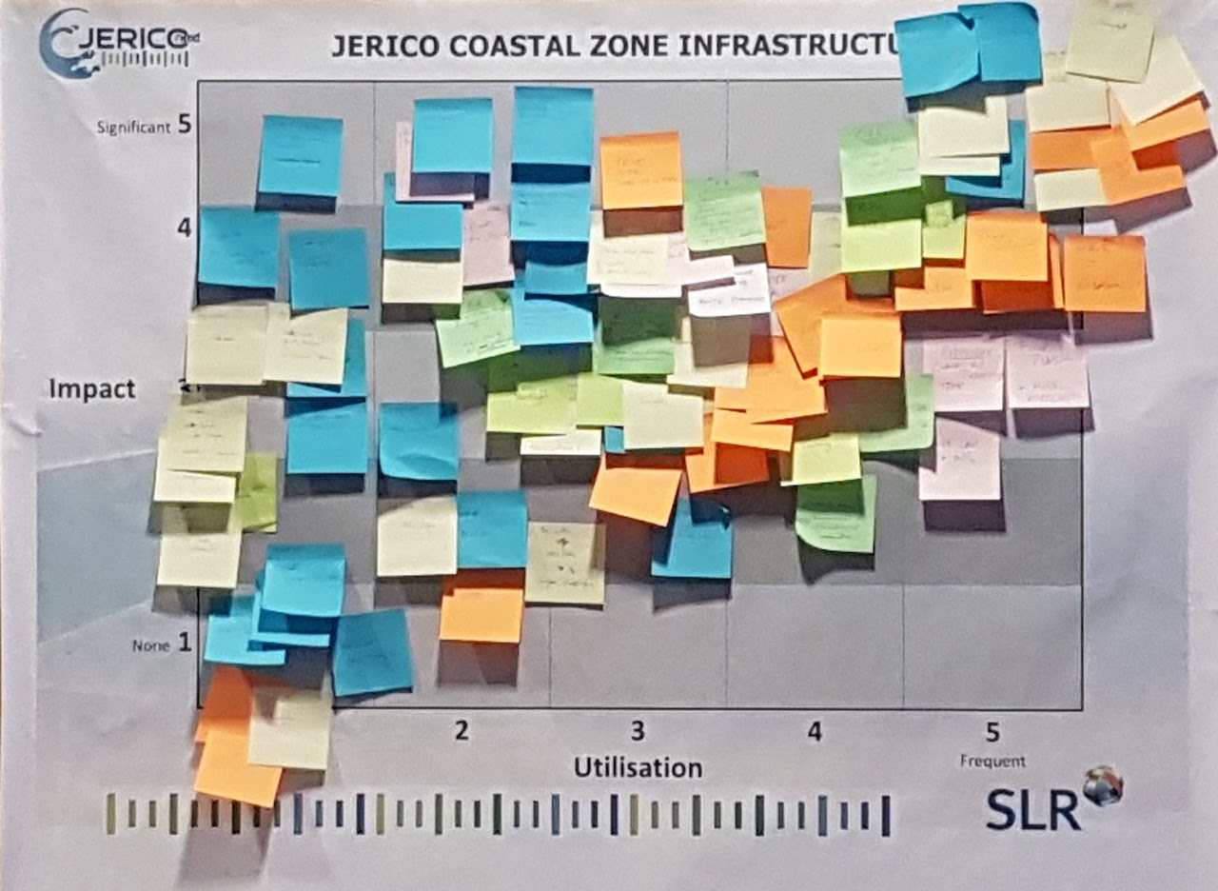

Antoine Mangin said that marketing in-situ data is difficult. This has to be done together with modelling and remote sensing. However, he is sure that there is the need for in-situ data to calibrate and fine tune the models.

Emma Heslop pointed out that the pattern for the blue growth industry should be evident. This is where governments and companies will invest.

Bill Turrell suggested that more instruments should be put on commercial fleets to gather data. He also pointed out that different sectors are richer than others. Therefore, investment will be different.

David Mills said that layers of complexity could be added to this exercise. It was necessary to think about the lifetime of the activity. There is the initial site selection phase, and a decommissioning phase. There is also the acquisition time of data. In a lifetime of 100 years, JERICO-NEXT would be interested in making predictions. It is important to see whether data has to be in real-time or delayed mode. For instance, for an impact assessment, delayed mode may be enough.

Dominique Durand said that the exercise should not stop here. The services at the top right quadrant are not JERICO-NEXT products. Therefore, s three or four products are needed in this area that come out from the JERICO-NEXT infrastructure. He also emphasised that services in the bottom left quadrant that appear to be of low priority at the present time should not be ignored because they may have a very significant impact in the future.

Antoine Mangin said that JERICO-NEXT has to build success stories in the frame of the project. Services should be selected from the top right quadrant and promoted with equipment manufacturers in the private sector. Also, JERICO-NEXT and science should be linked. Dominique Durand replied that there is a lot of competition when it comes to services in this quadrant (5,5). He thinks that the best approach is to look at the top left quadrant (high impact data that is needed, but not available) and try to get the private sector to invest in this. Antoine Mangin said that although the data are useful, they are not available. These services need to be moved from the top left part to the top right part of the chart.
Glenn Nolan said that industries do not distinguish between remote sensing, in-situ or models. They treat everything as information.

In summary, the feedback form the participants in the workshop highlighted a few points:
- Meteorological, metocean and water quality data, modelling and forecasting are frequently requested and have a high impact on business decisions in the shipping, marine renewable energy, oil and gas and ports and harbours sectors. Offshore wind is a rapidly growing business sector. JERICO-NEXT activities in these areas will be promoted to companies in these sectors.
- The application of acoustics, analysis of images and videos and cost effective monitoring of marine contaminants could have a higher impact on business decisions if they were better developed and more available to companies. JERICO-NEXT partners will be encouraged to further develop these services.
- Companies that are downstream data users need data modelling decision support systems with a predictive element. For example, metocean conditions for route planning in shipping and offshore operations planning in oil and gas, harmful algal blooms in aquaculture, jellyfish and water quality in marine tourism. The private sector “intermediary” companies will be contacted to further develop these services in conjunction with JERICO-NEXT Research Infrastructure (RI) partners.
- There is a need for long term performance validation for European sensor developers to make them more competitive in the international market. The JERICO-NEXT RIs can provide the independent verification required. The metrology capacity of the JERICO-NEXT RIs will be promoted to equipment manufacturing companies.
- There are many success stories within JERICO-NEXT that will be promoted to industry e.g. the winners of the Nutrient Sensor Challenge at the Association for the Sciences of Limnology & Oceanography Aquatic Sciences (ASLO) meeting in Honolulu, Hawaii, on Thursday, March 2 was Systea S.p.A. who participated in JERICO-NEXT TNA and were subsequently contracted by Fugro Norway A.S. to provide three systems.

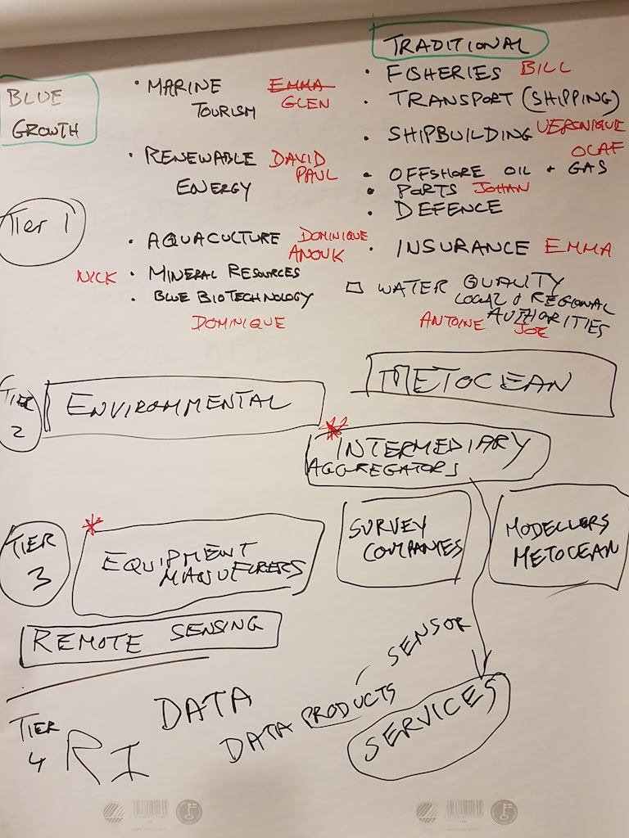

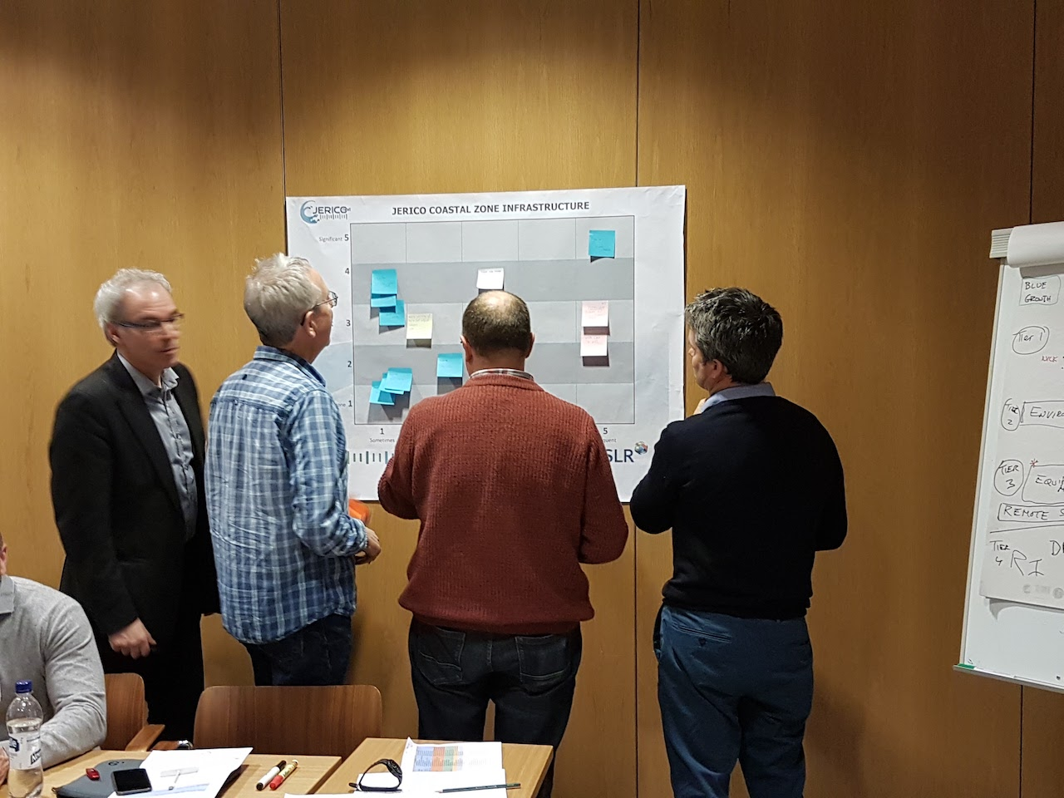

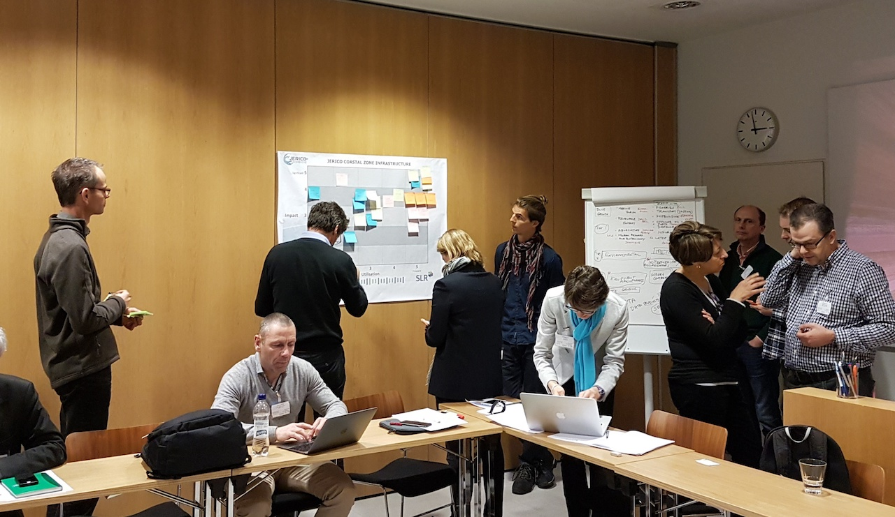

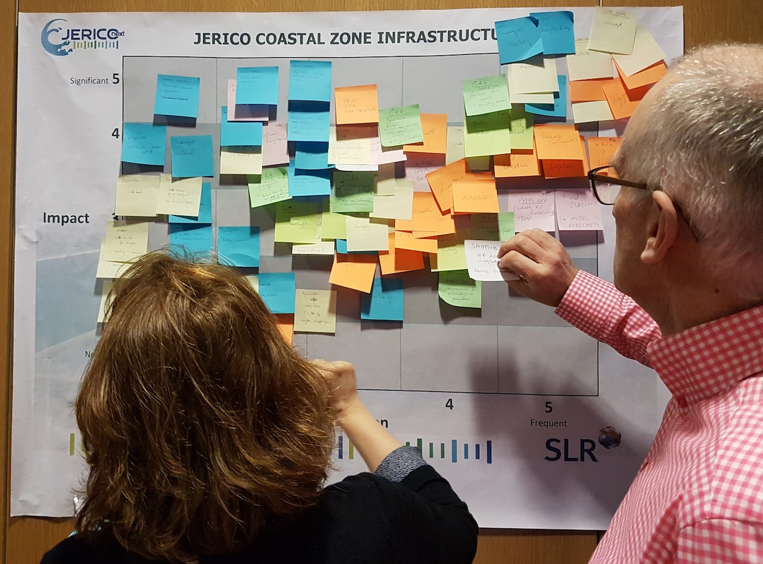

Session 5: What is the strategy to communicate with the key user groups?
Simon Keeble, WP8 Leader

Simon Keeble proposed the development of an interactive map to help define what the JERICO-NEXT Research Infrastructure looks like and the landscape it is in. This would not contain data but information layers about what the system looks like. This kind of product could also be created in collaboration with other projects, such as AtlantOS.

Emma Heslop pointed out that there should be a temporal component to such a map. Because gliders and floats move around, visualisations could be updated on a weekly basis.

The map will not represent data. This will show the regions over which services are available; i.e. shapes not just dots.
Glenn Nolan said that dots for TNA was ok., However, if ferryboxes, ARGOs, etc. are added, the map will get crowded very quickly. Some way to present layers of information to users based on their interests would be needed.

Such maps are good for a desktop or laptop computer. But for a smartphone, maybe it is better to just show a table.
David Mills said that another interesting feature could be to see the observations made in less than 10m water depth, or those related to climate change. There can be different views according to which section the user is coming from. For instance, if a user is interested in MFSD, it would be helpful to see which are the reporting areas.

Glenn Nolan suggested also adding dots on where key technologies are being developed (such as, for instance, where the CO₂ sensor is developed). This can be something like an ‘Innovation’ layer.

Antoine MANGIN said that the assimilation of offshore data is possible because the spatial and temporal resolutions are right. However, the interactions of coastal waters are very complex for this.

In general, the product suggestion was well received. JERICO-NEXT should start thinking about the layers and move forward.

Session 6: Summary the workshop and future steps
for keeping JERICO-NEXT in target and close
The report of the User Engagement Panel was available in May 2017 and participants were invited to make further comments.

The User Engagement Panel agreed to a proposed meeting at Oceanology in March 2018.

Antoine Mangin said that his organisation had been working on the use of bio-argo with remote sensing. This had been successfully for three years and that this can also be deployed in JERICO-NEXT. The main goal is to capitalise on two sources of information which are not very accurate. Therefore, the uncertainties of the data should be known before mixing the data together. There was a push to derive a time series for climate change initiative, but the intention was to merge the data to build a reliable time series, the uncertainties the result should be known. JERICO-NEXT should try to simplify access to the data in the 16 VA services. The project could help to create one simple registration form that will give access to all systems. Stefania Sparnocchia commented that sometimes the registration was needed to keep track of the people that are accessing the system. Veronique Creach said that at the moment, only one service provider requires registration.

Olaf Sveggen said that his organisation had bought three sensors that were developed through TNA, which had won the award. The sensors were working well. However, when they were deployed in clear water, the detection limit of the sensor was too high and no information was recorded. Maybe JERCO-NEXT could help to provide this type of calibration. JERICO-NEXT can act as a third party to test and provide these detection limits and sensor characteristics. Dominique Durand commented on this and said that the JERICO-NEXT label is an ongoing effort. One has to also keep in mind several factors such as how the instrument is deployed and how it behaves in different environments.

Laurent Coppola said that there should be more focus on the quality of data.

Emma Heslop said that it is a good idea to combine data, but the metadata should be looked at from the user side. Metadata for the biological parameters was needed.

Jo Foden said that the TNA awards were about 20k to 30k EUR each. Maybe smaller amounts should be assigned to fund more proposals. Veronique Creach suggested that 20k EUR is already not enough. Simon Keeble commented that for small-medium sized enterprises (SMEs) (start-ups), 20k EUR is already lot of money. He then suggested an open call so that people can submit an interest online anytime. Glen Nolan also thought that smaller grants will allow for more flexibility. Nick O Neil said that the primary interest of companies is to get their equipment certified. In most cases, access is a much bigger problem than money. Stefania Sparnocchia thought that the TNA application procedure is already very simple. This only involves filling in half a page about the project and some administrative information. An open call is possible, but the selection panel cannot meet any time. The office has limited amount of time.

At the end the meeting, everyone was asked to comment about the most valuable discussion of the day, the connections they made, and to recommend the priorities of JERICO-NEXT.
Antoine Mangin: The most valuable is to go a step further and start forming part of this community to know about the tools available. The next priority should be to make the link between users and industry. Four to five parameters with highest impact should be selected and make two to three success stories that link with JERICO-NEXT.

Bill Turrell: Most interesting thing was to learn about JERICO-NEXT, VA and TNA. Really enjoyed the private sector exercise. 20 years ago, the TNA situation would have been the opposite. This may indicate that EU funding has worked in the Mediterranean and stopped in northern Europe. He would try to promote JERICO-NEXT.

Glenn Nolan: It was helpful to understand the VA and TNA as he didn’t know what to expect from them. It is important to introduce more flexibility to TNAs. Site registration is a barrier for VA and this should be avoided.

Emma Heslop: Enjoyed listening and that the categorisation of data is even important at the end user sector. A way should be found to visual the data and think about keywords. Define what integration means because there is patchiness in communication.

Anouk Blauw: Really liked the four-tier approach in the business exercise. It gives an idea of what the user wants. Also, liked listening about the margin in the variance of chlorophyll data. His organisation is working on this.

David Mills: It was good to think again about JERICO-NEXT. This forced him to look through things from a different perspective. The decision on how to engage in face-to-face meetings is important. Regarding TNA, he will look for opportunities from the academic sector especially those related to renewable energy section such as, for instance, how biota can be verified from TNA. It is important to identify two to three products and services that are top left in the chart produced in the business exercise, and work with these users to co-develop products with the users.

Veronique Creach – VA would like to have something more visible. Wish that the providers would be a little more active and would like to have more contact with them. JERICO-NEXT needs to be promoted. Liked the approach of Nick O’Neill. Interesting to see how to approach the user and the industry.

Nick O'Neill: If long term validation performance for European sensor developers can be done, the Americans would be beaten. It is important to improve data access. This should be top priority. Some of the things do not have to be gold plated, but are producing good results.

Paul Gaughan: Found the TNA and VA information useful and some of the complications involved. It is important to promote test cases for sustainability. It is good to see that the infrastructure and scientific expertise are there.

Olaf Sveggen: Learnt a lot about JERICO-NEXT. Sometimes his organisation receives requests from clients that cannot be responded to. However, by meeting JERICO-NEXT people, positive feedback can be given. The focus areas should be the quality and validation of data (especially that related to water quality). Offshore wind is also a very fast growing business for different groups. These need sea currents profiles, waves and wind information. Interesting discussion with all partners.

Johan Vercruysse: This was the first contact with JERICO-NEXT. Valuable to look from the point of view of the user as a provider of data. Learned about TNA and VA.
Laura Beranzoli: The discussion was interesting. The issues related to VA and the development of relationship/tools to meet the user needs, are all the same in every project. With regard to VA, it was important to see what is already operating and make this available. There is no need to reinvent the wheel. Most of the websites are not regularly updated.
Stefania Sparnocchia: For TNA, it was interesting because when something is proposed that is not currently feasible because of EU rules, JERICO-NEXT can adopt it because it is an independent infrastructure. All partners should be proactive.

Dominique Durand: Thought the UP members were the right people. Really liked how they interacted with the JERICO-NEXT partners. The discussions showed that the framework given by the European Commission is too tight to be completed. It is important to think more outside the box. It is necessary to work to qualify instruments. It will be good to elaborate on this and to do success stories with Copernicus.

Laurent Coppola: Liked presentation on VA. The quality of the data that is being provided must be assured and the providers need to be pushed to deliver data on time. Data on the VA website should be reviewed and if people do not provide the data, they will not be given the money.

Patrick Farcy: It is important to have such exchanges and discussion with persons that are not involved in the project. It is important for VA to know what can be done to improve the service. Information and suggestions are always very important – even simple, but efficient ones. During the TNA discussions, SMEs were discussed. However, it is not easy for JERICO-NEXT to involve these without them answering to the calls. Maybe the problem is that SMEs are being asked to go and work outside their country. JERICO-NEXT partners need to do their best to have better communication with these and ask them to answer the calls.

Simon Keeble: Agreed with Patrick’s comments. It was valuable to go through these services with a different group of people. It is important to discuss how to take the services and data forward.

