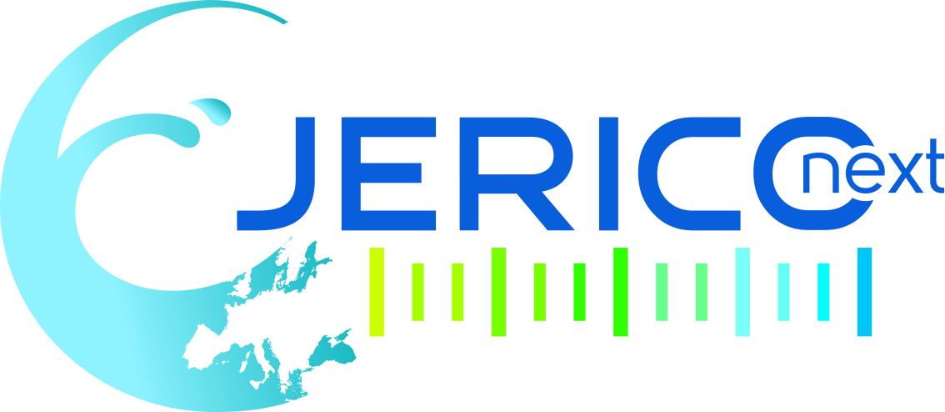

JOINT WP2-WP5 WORKSHOP
ASSIMILATING TECHNICAL BEST PRACTICE IMPROVEMENTS TO OPTIMIZE NETWORK DATA FLOW
Location: Bergen, Norway
Date: 05 October, 2017
Registration by 15 sept. 2017
There!

Aim of the workshop

Data are products of measurements, which are sensitive to many factors such as, for example, the technique and type of technology used to make them, the way the specific instruments are prepped, the kind of reference material employed, instrument deployment configurations, not to mention seasonality and other environmental influences. The full potential of collected data can be exploited only if they are adequately characterized on the basis of the effective qualities of the underlying measurements. This characterization is the domain of the data producer, whose aim is to maximize the relevance of collected data in relation to the stated objectives of the measuring activity. The aim of the data manager, on the other hand, is to assure that gathered data can reach the widest possible number of users intact, with sufficient knowledge regarding them to permit assessments of their fitness-for-purpose and subsequent utilization. Overall, the difference in aims can lead to inefficiencies in the accurate flow of information from the point of data collection to the final user of the data.

WP2 of JERICO-NEXT contains the initiatives planned to promote and facilitate the harmonization of the project’s observing network from the technical standpoint, principally through the promulgation of Best Practice as regards the technologies, methodologies and procedures underpinning actual measurements.

WP5 of JERICO-NEXT contains the initiatives aimed at providing procedures and methodologies to enable data collected through the project to enter mainstream marine data conduits, complying with the international standards regarding their quality and metadata.

As mentioned earlier, data producers and data managers tend to view data very differently. So, following discussions between the JERICO-NEXT management team and the WP2 and WP5 leaders, it has been decided to examine the possibilities for closer collaboration between the above two WPs in order to better reconcile contrasts arising from differences in the way data are regarded by the project’s observing and data management components. For the moment, the main areas for possible cooperation have been restricted to the following, though ideas to expand the sphere of collaboration further are welcome:
- HF-radar data;
- data relating to biology based on optical measurements,
- data on marine carbonate system variables;
- data from AUVs (gliders);
- platform registration and metadata management.

This workshop has been planned to gather the members of the WP2 and WP5 communities of JERICO-NEXT to try to:
- identify difficulties relative to current data-handling practices employed within the project;
- provide clearer terms of reference for handling JERICO-NEXT data;
- agree on more appropriate metadata requirements for JERICO-NEXT data, if needed.

More information: jerico@ifremer.fr

Venue

This is a side event of the EuroGOOS conference to be held in Bergen the 3-5 Oct. 2017 at the Scandic Bergen City Hotel

For more information about the conference:
http://eurogoos.eu/events/eurogoos-international-conference/ (specific registration)

Registration to the workshop

Registration by 15 sept. 2017
There!

AGENDA

Thursday, October 05, 2017 (afternoon)
Joint WP2-WP5 Workshop: Assimilating technical Best Practice Improvements to optimize network data flow

From - to | Title
13:50-14:00 | Overview of WP2 and WP5 of JERICO-NEXT (R. Nair, OGS/W. Petersen, HZG, L. Perivoliotis HCMR)
14:00-14:15 | HF radar observations: the data producer’s perspective.  Julian Mader, AZTI
14:15-14:30 | HF radar observations: the data manager’s perspective  Antonio Novellino, ETT
14:30-15:00 | Discussion
15:00-15:15 | Observations using AUVs: the data producer’s perspective  John Allen, SOCIB
15:15-15:30 | Observations using AUVs: the data manager’s perspective  Thierry Carval, Ifremer
15:30-16:00 | Discussion
16:00-16:20 | Coffee break
16:20-16:35 | Marine carbonate system observations: the data producer’s perspective Andrew King or Kai Sorenson, NIVA (TBC)
16:35-16:50 | Marine carbonate system observations: the data manager’s perspective Benjamin Pfeil, University of Bergen
16:50-17:20 | Discussion
17:20-17:35 | Biological observations using optics: the data producer’s perspective Jukka Seppala, SYKE
17:35-17:50 | Biological observations using optics: the data manager’s perspective Johanna Linders or Bengt Karlson, SMHI (TBC)
17:50-18:30 | Discussion

Version: 6 sept. 2017

