Calibration Experiments at Ifremer Metrology Laboratory
Plouzané (near Brest), France
8-12 October 2012

In parallel with the Seatechweek event, we propose you to carry out some calibration experiments in Ifremer Metrology laboratory:
(http://www.ifremer.fr/ic/fr/etalonna_moyens.htm (French website)
These experiments consist in temperature, salinity (conductivity) and oxygen calibrations. Our facilities can hold a maximum of 10 probes (depending on the size of the probes). That’s why we limit the number of probes per participant to 1.

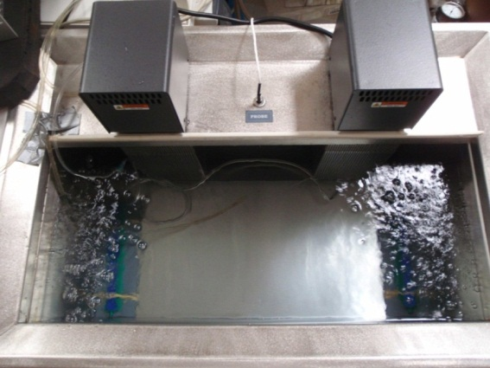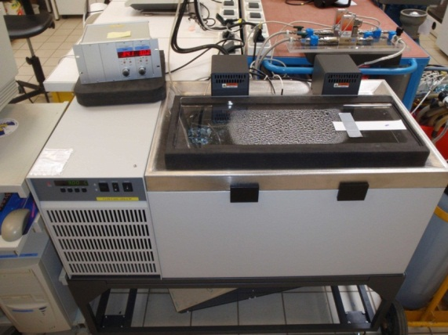
Oxygen bath (100 liters)

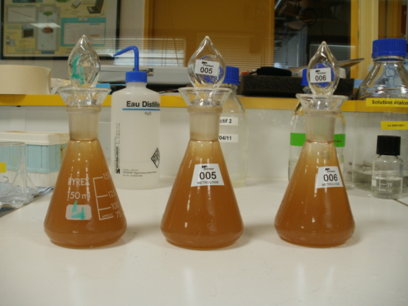
Winkler sampling
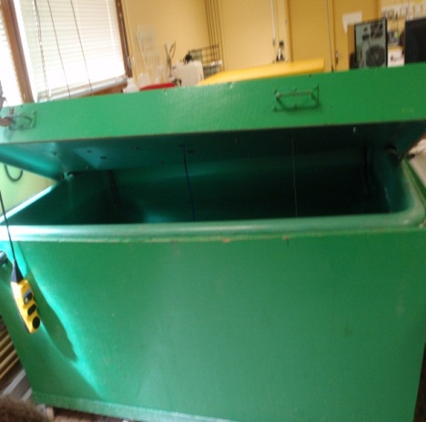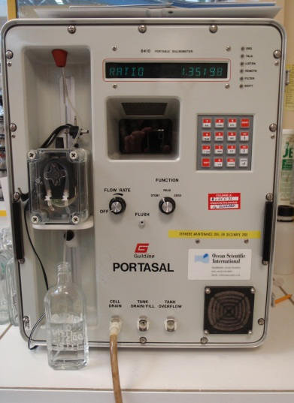
Temperature/conductivity bath (800 liters) Salinometer
The aim of these experiments is to compare the calibration methods used by each laboratory. To be efficient, we are asking you to come with the last calibration result of your probe (trueness and uncertainty).
The proposed schedule is:
Date | Sensors | Description
Monday afternoon | All probes | - Probes installation in the conductivity/temperature bath  - Visit of metrology laboratory and nutrients laboratory
Tuesday morning | Conductivity/Salinity/Temperature | Calibration at salinity 35 and temperature 5°C
Tuesday afternoon | Conductivity/Salinity/Temperature | Calibration at salinity 35 and temperature 15°C
Wednesday morning | Conductivity/Salinity/Temperature | Calibration at salinity 10 and temperature 15°C
Wednesday afternoon | Conductivity/Salinity/Temperature | - Calibration at salinity 17 and temperature 15°C  - Probes installation in the oxygen bench
Thursday morning | Oxygen/Temperature | Calibration at O2: 100% (air equilibrium or nitrogen/oxygen bubbling) and temperature 20°C (salinity: 0)
Thursday afternoon | Oxygen/Temperature | Calibration at O2: 100% (air equilibrium or nitrogen/oxygen bubbling) and temperature 10°C (salinity: 0)
Friday morning | Oxygen/Temperature | Calibration at O2: 50% (nitrogen/oxygen bubbling) and temperature 20°C or 10°C (salinity: 0)

OUTCOME:
Participants will be issued with calibration certificates.
Besides, if participants can bring their home calibration certificate or results (trueness and uncertainty), we propose to compare the calibration results, to calculate the normalized En scores and to summarize the experiments and the results in a report.

CONTACT:
For any suggestion don’t hesitate to contact us.
Contact person: florence.salvetat@ifremer.fr.

REGISTRATION:
If you are interested, please register at
http://www.jerico-fp7.eu/coastal-technologies/in-lab-and-in-field-experiements.
Fill up the registration form and send it to: florence.salvetat@ifremer.fr
Registration deadline is: 27 SEPT 2012.

