Marine Institute, Rinville, Oranmore, Co. Galway, Ireland H91 R673

PRACTICAL INFORMATION

How to get here?

From the Airport: You have the option to fly into either Dublin or Shannon Airport.
Shannon Airport
Shannon is the closest airport to Galway - 85km or 1 hour 15 minutes by car. There is a bus route 51 which connects Shannon to Ennis and Galway (originates in Cork). Please see link:
http://www.buseireann.ie/inner.php?id=406&form-view-timetables-from=Shannon+Airport+%28Departures+Gate%29&form-view-timetables-to=Galway+%28Bus+Station%29&form-view-timetables-route=&form-view-timetables-submit=1
You can arrange car rental or schedule a Car/Mini-bus transfer - https://www.galwayshuttle.com/ Approx €95 each way or http://www.shannonairportcab.com/ Phone: +353 (0)61 471538
Dublin Airport
Dublin is 215km or 2.5 hours by car from Galway. There is a very good direct non-stop bus service so if flying to Dublin, this would be the recommended option. You can use one of the following companies - http://www.gobus.ie or http://www.citylink.ie. The Galway Bus station is in Galway city centre. You could also catch a train to Galway from Dublin’s Heuston Station (http://www.irishrail.ie/fares-and-tickets/dublin-galway). Heuston station is circa 30 minutes by taxi from Dublin airport, depending on traffic.
Airport Buses from Dublin
Citylink – www.citylink.ie
Dublin to Galway Route Return – tickets cost around €30.

GoBus - www.gobus.ie
Dublin to Galway Route Return – tickets cost around €30.

Bus Eireann – www.buseireann.ie
Dublin Airport to Galway Return – tickets cost around €30.

Travel time by bus from Dublin airport to Dublin can vary between two and half hours to three hours (some routes go through Dublin centre, others are direct routes from the airport to Galway). Please keep this in mind when booking your bus and plane tickets.

Trains from Dublin
Trains run from Dublin city to Galway city on a daily basis however you need to get a taxi from Dublin airport to Heuston Station in Dublin city. The taxi journey takes about 20mins. Train times and tickets are available on www.irishrail.ie . Train tickets cost about €35 and the journey takes about 2 and half hours.

Car Hire
www.rentalcars.com/ireland
www.arguscarhire.ie
www.budget.ie

SUGGESTED ACCOMMODATION

Harbour Hotel
New Dock Road
Galway City
Tel: +353 91 894800
Email: stay@harbour.ie
Website: http://www.harbour.ie/ (MI room rate of €149.00 B&B per night.)

Radisson Hotel
Lough Atalia Road
Galway City
H91 CYN3
Tel: +353 91 538 300
Email: reservations.galway@radissonblu.com
Website: www.radissonhotelgalway.com/

Jury’s Inn Galway
Quay Street
Galway City
H91 E8D7
Tel: +353 91 566444
Email: jurysinngalway@jurysinns.com
Website: www.jurysinns.com/hotels/galway

The House Hotel
Lower Merchants Road,
The Latin Quarter,
Galway City
Tel: +353 91 538900
Email: info@thehousehotel.ie
Website: www.thehousehotel.ie

Here are some more of the larger hotels in galway city in addition to the list i sent on earlier....

https://www.theconnacht.ie

https://www.claytonhotelgalway.ie

https://www.maldronhotelsandyroadgalway.com

https://www.menloparkhotel.com

Below are 2 hotels outside galway city but closer to the marine institute.

https://www.oranmorelodge.ie

https://ie.hotels.com/ho205578/maldron-hotel-oranmore-galway-oranmore-ireland/

MAP

The Marine Institute Headquarters are situated in Rinville, Oranmore approx. 10KM from Galway City. You will have to account for about 20 to 30 minutes taxi travel time from Galway City to Rinville.
A Dedicated Bus shuttle bus service will pick up at the Harbour Hotel location in the City center to bring assembly attendees to the Marine Institute and drop them back to the city centre in the evening for the 3 days of the General Assembly meeting.

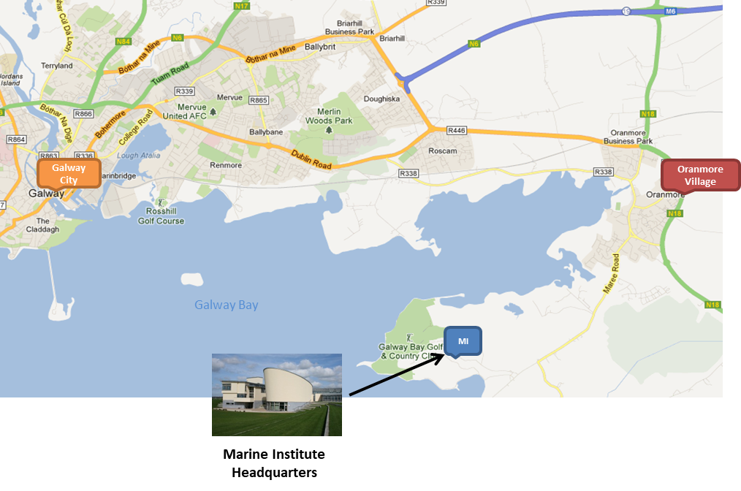
Maps of Galway city:
https://www.maps.ie/galway-city.htm
https://www.galwaytourism.ie/UserFiles/Image/galway-tourist-map.pdf

Restaurants in Galway City Centre
https://brasseriegalway.com/
http://kirwanslane.com/
http://www.oscarsseafoodbistro.com/
http://kaicaferestaurant.com/
http://www.johnkeoghs.ie/

Galway Taxis:
http://www.galwaytaxis.com/
http://www.bigotaxis.com/

Jerico Next Ice Breaker Event – September 24th @20:00-22:00

JERICO-NEXT: General Assembly: Ice Breaker
Who should attend: All partners welcome
Location: The Oslo Bar, 226 Upper Salthill, Galway
http://www.galwaybaybrewery.com/oslo/
Bus Information: Bus Éireann #401: http://www.buseireann.ie/timetables/1425472464-401.pdf
Bus Stops: Galway City Stop (Eyre Square), Salthill stop (Upper Salthill Road – Canton Kitchen)
Oslo Bar is located ~5min walk (towards the seafront) from Canton Kitchen restaurant (bus stop)

Jerico Next Project Dinner - September 26th @19:00-23:00

All partners welcome
Location: Corrib Princess. Boat departs: Waterside, Woodquay, Galway.
http://www.corribprincess.ie/index.php/corrib-princess-contact
*Please inform us in Advance of any special Dietary requirements*

Tour to Cliffs of Moher or Connemara – Optional Friday 28th

If there is sufficient interest and numbers we can look at organizing a bus/boat Tour to the Cliffs of Moher or Connemara (approx. €45 per person)
Example: https://doolin2aranferries.rezgo.com/details/132742/super-combo-tour-from-galway/

